**Student Assessment Submission and Declaration**

When submitting evidence for assessment, each student must sign a declaration confirming that the work is their own.

|  |  |  |  |
| --- | --- | --- | --- |
| Student name: Rashed Hassan | | Assessor name: | |
| Issue date (1St Submission): | Submission date (1St Submission): | | Submitted on: |
| In case of resubmission | | | |
| Issue date (1St Submission): | Submission date (1St Submission): | | Submitted on: |
| Programme:  **HND in Computing - Software Engineering**  **HND in Computing - Cyber Security**  **HND in Computing - Intelligent Systems** | | | |
|  | | | |
| Assignment number and title: **1 Movie Zone Database System** | | | |

**Task1:**

As a first stage, the task that is assigned to you is the design of the database system, you are required to perform the following:

1. Investigate and document at least 10 system and user requirements based on the given scenario.

**Answer:**

User requirements:

• The customer must have an account with a unique identification number indicating his/her national identity.

• Required Personal Information Name (first name, middle name and last name), phone number (one or more), date of birth, gender, address, nationality and date of birth.

3 - The customer must have an account registered in the system to allow the customer to access all data

Each customer can book more than one movie.

5- The customer can purchase or retrieve tickets through the website or application.

6 - Allows the customer to search for a movie, find out the specific type of movie, book the movie and other additional services.

7- The website or application must be easy to use and how to deal with it for the user.

8- Also, the web screen must display a login screen for the user so that the user can access his account at anytime and anywhere

9. The application or website must also be able to customize the user experience based on factors such as the user's location, past behavior, and preferences.

10. User-friendly website/application interface and easy handling.

11. There must be all the start and end times for all films and the date of the day on which they will be shown.

12. There should be information specifying the type of movie and what is the minimum age allowed to watch it.

System Requirements:

1 - In the movie area, all data in the movie area should be about the movies that need to be shown to customers.

2 - The system must be secure.

3 - The system requires a system for their employees to facilitate and organize the movie reservation process.

4 - There must be a database to store user data and information.

5 - A server must be available for downloading the database as well as for accessing it or for retrieving information.

6 - All hardware and software must be available to employees or developers to create a database.

7- The system must prevent the creation of customer accounts with duplicate email addresses.

8- The system must impose a minimum revenue of $100 for films.

9- The system must fill the nationality field with the word "Jordanian" if it is not provided by the customer.

1. Outline the database system by designing the appropriate Entity Relationship Diagram (ERD).

Answer:

Entities and the attributes:

Customer (National ID, Name, Mid name, Last name, phone number, Birth date, Gender, Address, Nationality).

Movie (Movie id, Movie title, year, duration, revenue).

Genre (genre id, genre name).

Production companies (Company id, name, address, phone number).

|  |  |
| --- | --- |
| **Entities** | **Attributes** |
| Customer | (National ID, Name, Mid name, Last name, phone number, Birth date, Gender, Address, Nationality, age). |
| Movie | (Movie id, Movie title, year, duration, revenue). |
| Genre | (genre id, genre name). |
| Production companies | (Company id, name, address, phone number). |
|  |  |

|  |  |
| --- | --- |
| Customer |  |
| Movie | **- Customer reserve movie.**  **N - M (**Many to manyrelationship) |
| Genre | **- Movie related to Genre.**  **N - M** (Many to many relationship) |
| Production companies | **- Production companies produce movie.**  **1 - M (one to many relationship)** |

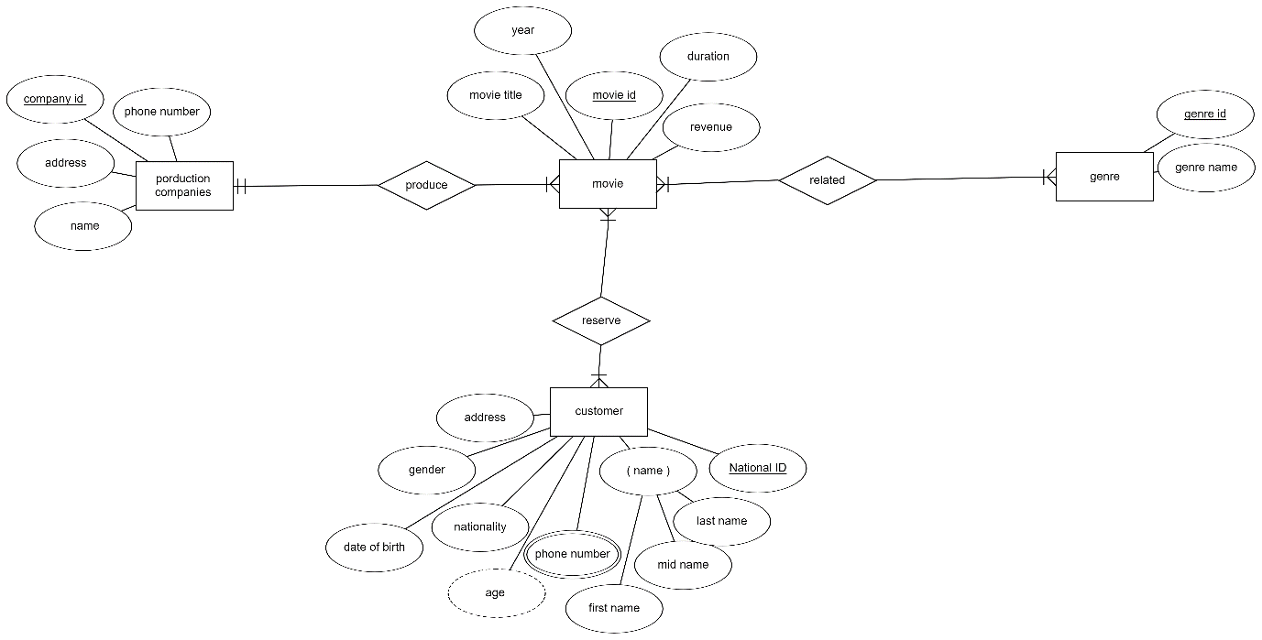

3. Create the relational database which includes:

* 1. List of tables mapped from the ERD
  2. Database schema which includes the fields, datatypes and constraints (data validation), identifiers (primary keys and foreign keys).

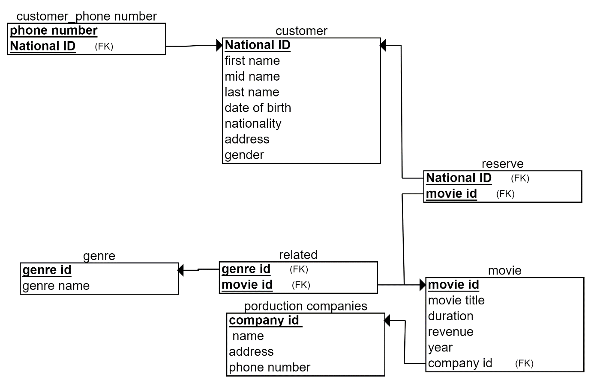

|  |
| --- |
| Customer |
| National ID | INTGER, PK, NOT NULL, UNIQUE. |
| Frist name | VARCHAR (20), NOT NULL |
| Mid name | VARCHAR (20), NOT NULL |
| Last name | VARCHAR (20), NOT NULL |
| date of birth | VARCHAR (20), NOT NULL |
| nationality | VARCHAR, NOT NULL |
| address | VARCHAR, NOT NULL |
| gender | VARCHAR (8), NOT NULL |

|  |
| --- |
| Customer_phone number |
| Phone number | VARCHAR, NOT NULL |
| NATIONAL ID | FK |

|  |
| --- |
| reserve |
| National ID | FK |
| Movie id | FK |

|  |
| --- |
| genre |
| genre id | INTGER, PK, NOT NULL, UNIQUE |
| genre name | VARCHAR (25), NOT NULL |

|  |
| --- |
| Production companies_phone number |
| Phone number | VARCHAR, NOT NULL |
| Company ID | FK |

|  |
| --- |
| related |
| genre id | FK |
| movie id | FK |

|  |
| --- |
| Production companies |
| Company id | INTGER, PK, NOT NULL, UNIQUE. |
| name | VARCHAR (20), NOT NULL |
| address | VARCHAR (20), NOT NULL |

|  |
| --- |
| Movie |
| movie id | INTGER, PK, NOT NULL, UNIQUE. |
| movie title | VARCHAR (20), NOT NULL |
| duration | VARCHAR (20), NOT NULL |
| revenue | DOUBLE, NOT NULL |
| year | INTGER, NOT NULL |
| company id | FK |

4. Check whether the provided design is normalized. If not, normalize the database by removing the anomalies.

**Answer:**

Customer

|  |  |  |  |  |  |  |  |
| --- | --- | --- | --- | --- | --- | --- | --- |
| National ID | Name | Phone number | Age | Nationality | Date of birth | Gender | Address |

First:

Then, it is normalized because to the functional dependency.

Prime attribute 🡪 NationalId

Non- Prime attribute 🡪 (Name, Mid name, Last name, phone number, Birth date, Gender, Address, Nationality, age).

Movie

|  |  |  |  |  |  |
| --- | --- | --- | --- | --- | --- |
| Movie Id | Movie title | Revenue | Year | Duration | CompanyId |

Second:

Then,﻿﻿ this table is not normalized.

So, indeed, you have fulfilled the requirements of the first normal form (NF1). However too, it also still needs to meet the requirements of the second normal form (NF2), which will be the following table after we have fulfilled the requirements:

Movie

|  |  |  |  |  |
| --- | --- | --- | --- | --- |
| Movie Id | Movie title | Revenue | Year | Duration |

Prime attribute 🡪 Movie Id

Non- Prime attribute 🡪 (Movie title, year, duration, revenue).

Movie:

|  |  |  |
| --- | --- | --- |
| Movie Id | Revenue | Year |

Movie:

|  |  |  |
| --- | --- | --- |
| Movie Id | Movie Title | Duration |

Movie Production Companies:

|  |  |
| --- | --- |
| MovieId | CompanyId |

Production companies:

|  |  |  |  |
| --- | --- | --- | --- |
| Company Id | Name | Address | Phone number |

Third:

Then,﻿﻿ ﻿﻿ it is normalized because to the functional dependency.

Prime attribute 🡪 CompanyId

Non- Prime attribute 🡪 (name, address, phone number).

Genre:

|  |  |
| --- | --- |
| Genre Id | Genre name |

Fourthly:

Then,﻿﻿ ﻿﻿ it is normalized because to the functional dependency.

Prime attribute 🡪 GenreId

Non- Prime attribute 🡪 (genre name).

5.Design set of simple input and output (reports) interfaces for the project using Wireframe or any interface-designing tool.

6. Assess and validate your design with respect to given requirements, check whether all requirements are satisfied, show details on how you did your assessment.

**Answer:**



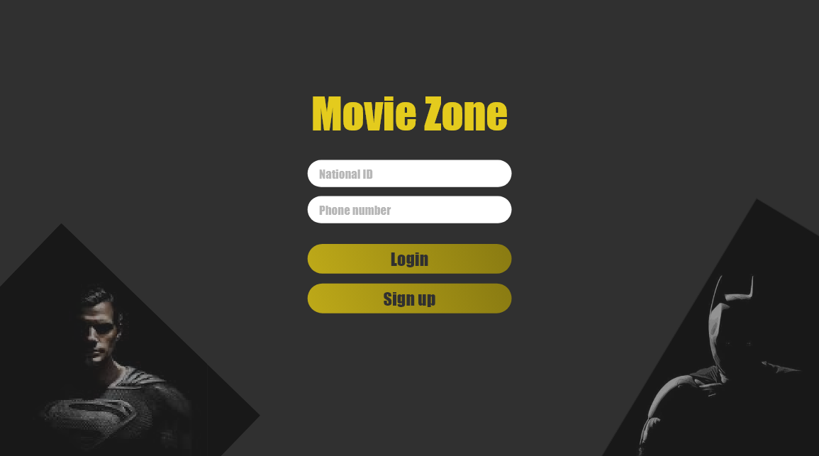

First, a welcome or start screen will appear for the customer, and after that it will appear that you are logging in if you have an account through the national number and that you are entering your phone number if you do not have an account by clicking on Create an account.

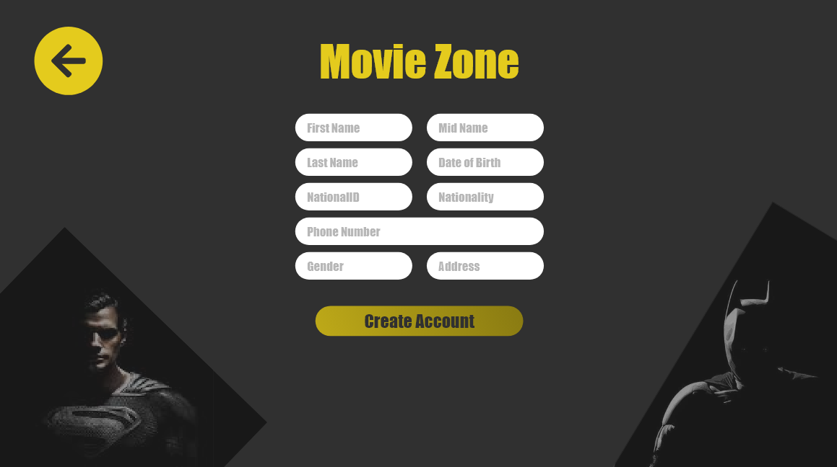

If you do not have an account already registered, create an account by entering your information, which is your first name, second name, last name, date of birth, national ID, nationality, phone number, gender, and finally the address, and then you click on create an account.

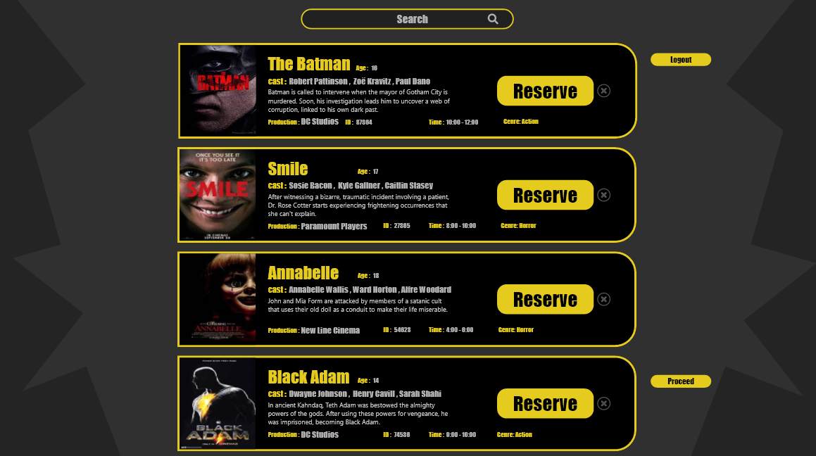

After you log in, a list of movies that will be shown today will appear to you, and you can make reservations. You also have the option to search and find out the type of movie, book the movie you want, and make a reservation. You can also book more than one movie.

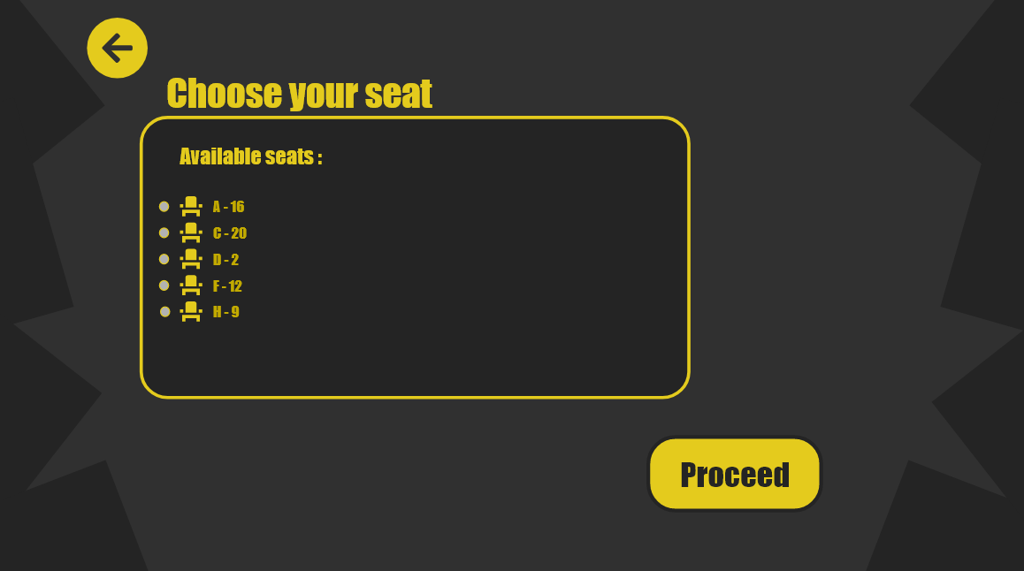

After you make a reservation, you will see a screen showing information about the hall and the available seats, by selecting the row and seat, and then clicking on proceed to complete the reservation process.

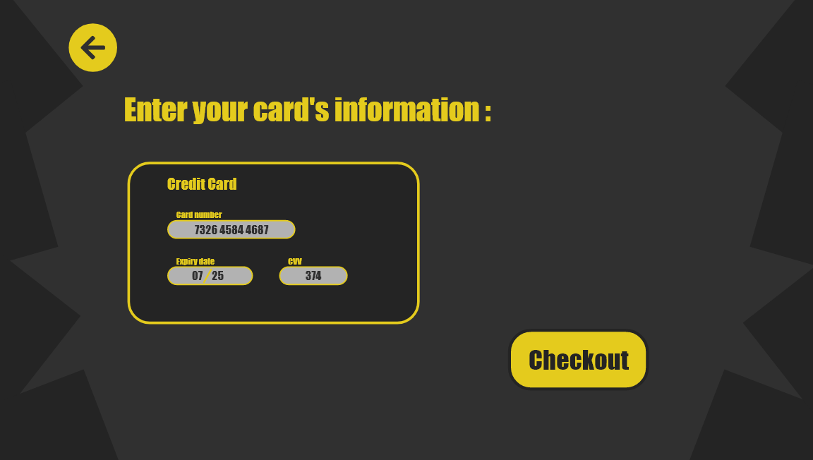

After that, the customer will see a screen containing information about the payment method through a credit card, and the customer will fill in his information through the card number, expiration date, and CVV, and then the customer will click on checkout.



Finally, a thank you screen will appear, and the customer will enjoy his reservation through the Movie Zone system.

**Task 2**

**Answer:**

**1)**

I used Microsoft Access to create the database

The SQL tables:

a- Customer Table:

create table Customer(

nationalId int primary key not null,

firstName varchar(20) not null,

midName varchar(20) not null,

lastName varchar(20) not null,

phoneNumber int not null,

age int not null,

nationality char(15),

dateOfBirth date,

address varchar(25) not null,

gender char(8) );

b- Movie Table:

create table Movie(

movieId int primary key,

movieTitle varchar(20) not null,

duration varchar(20) not null,

revenue double not null,

year int not null );

c- Production Companies Table:

create table production_companies(

companyId int primary key not null,

phoneNumber int not null,

address varchar(25) not null,

name varchar(25) not null);

d- Table Genre:

create table Genre(

genreId int primary key not null,

genreName varchar(25) not null);

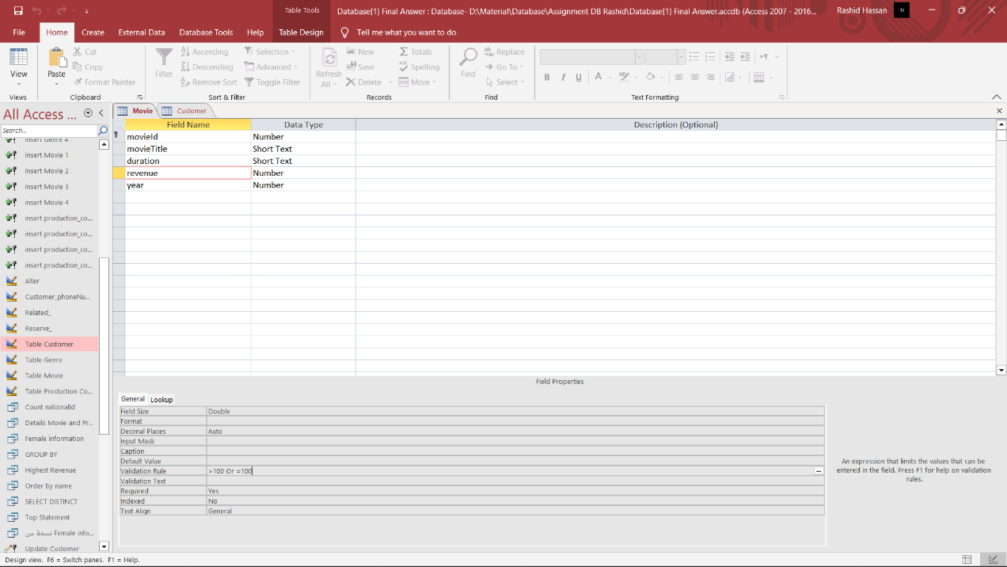

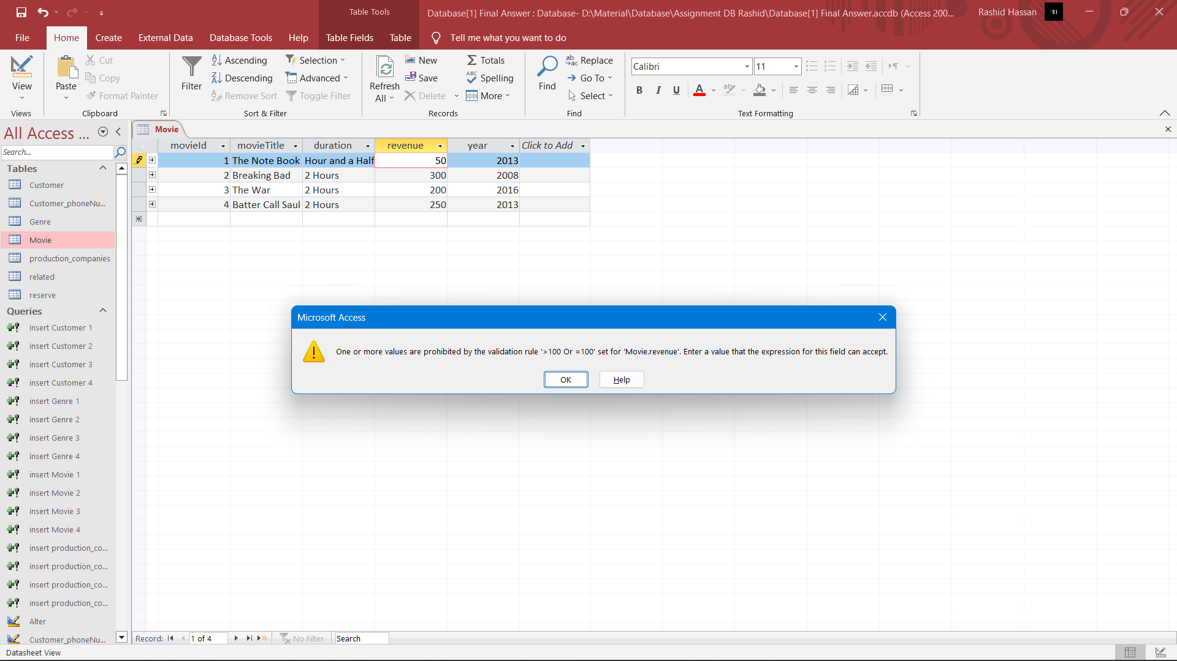

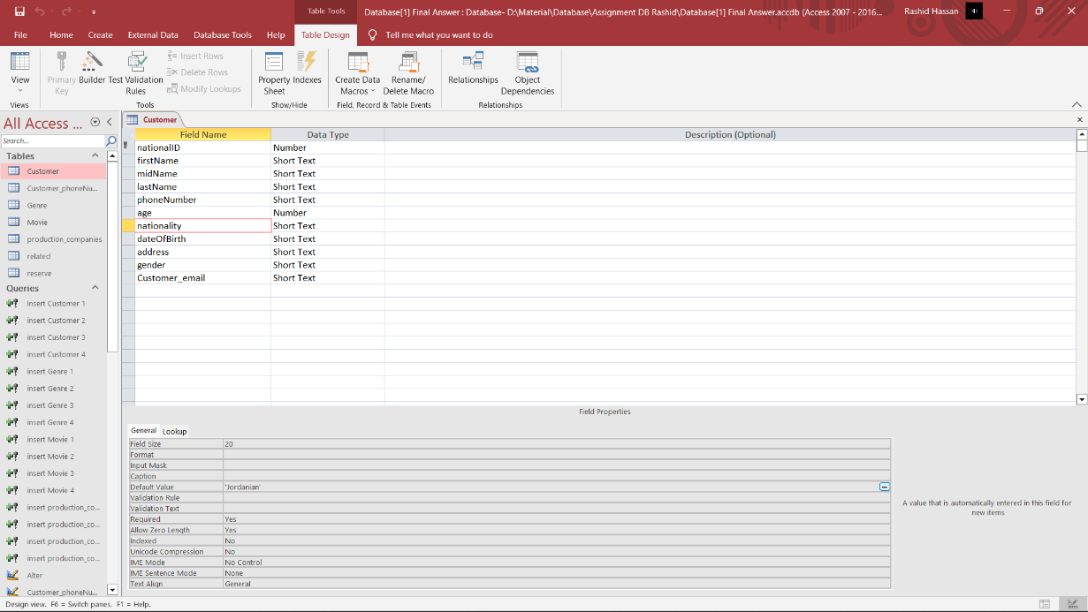

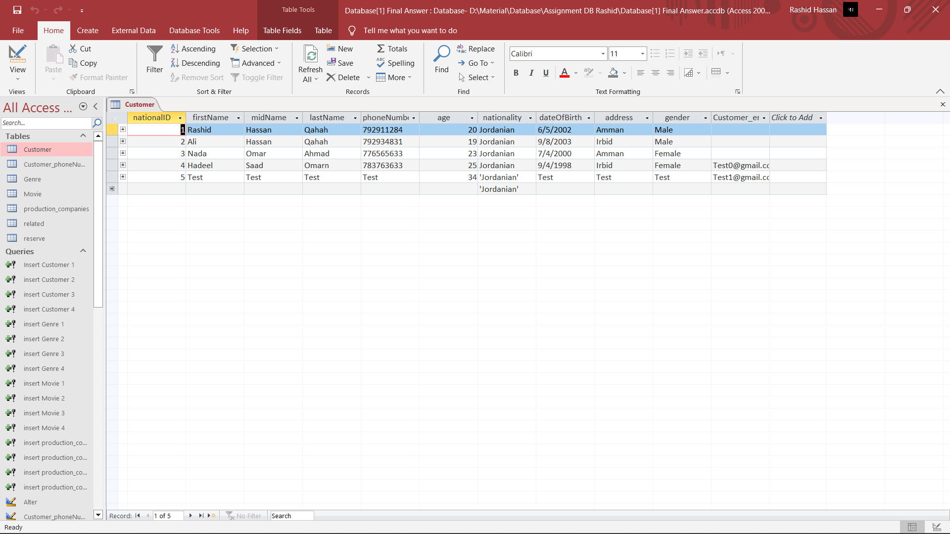

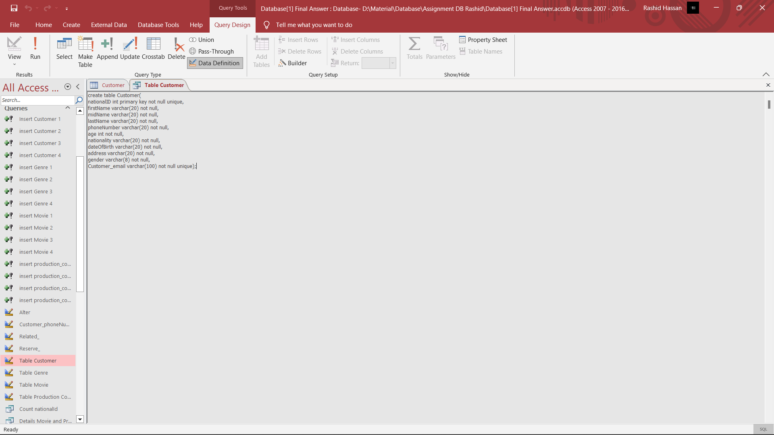

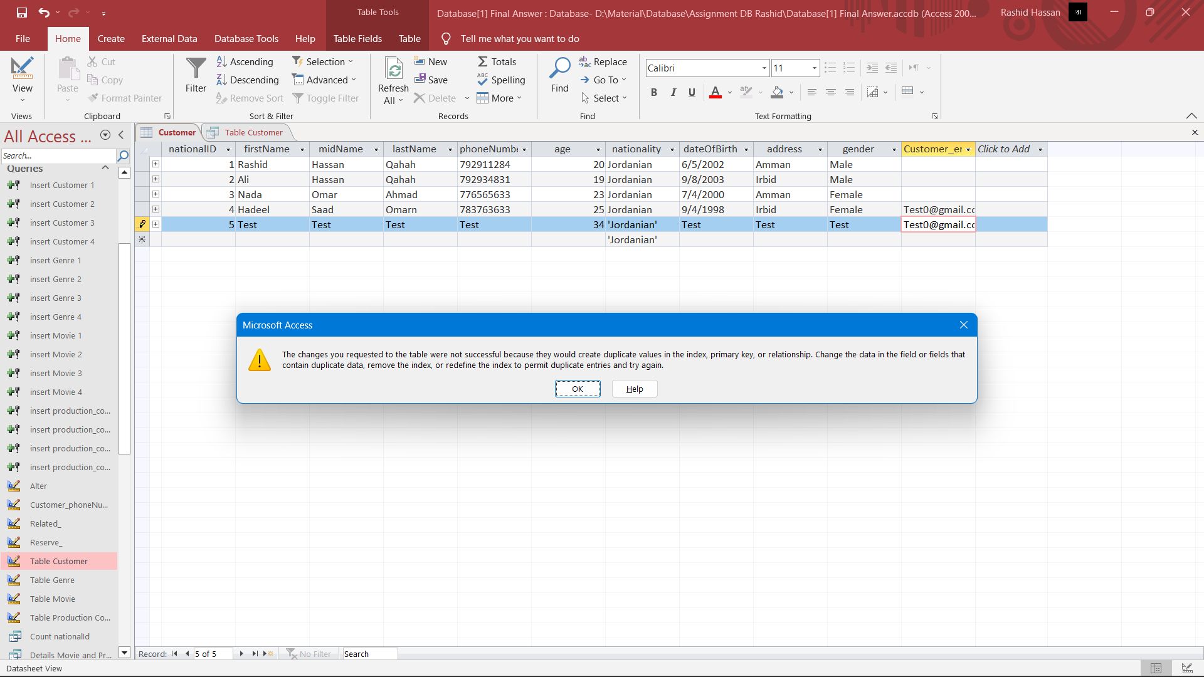

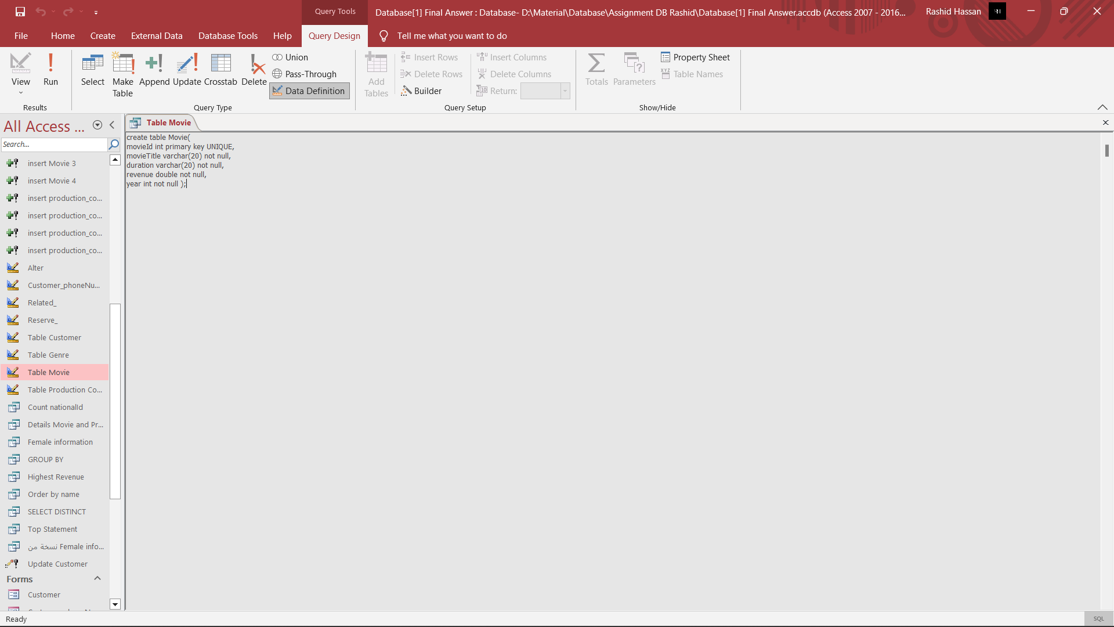

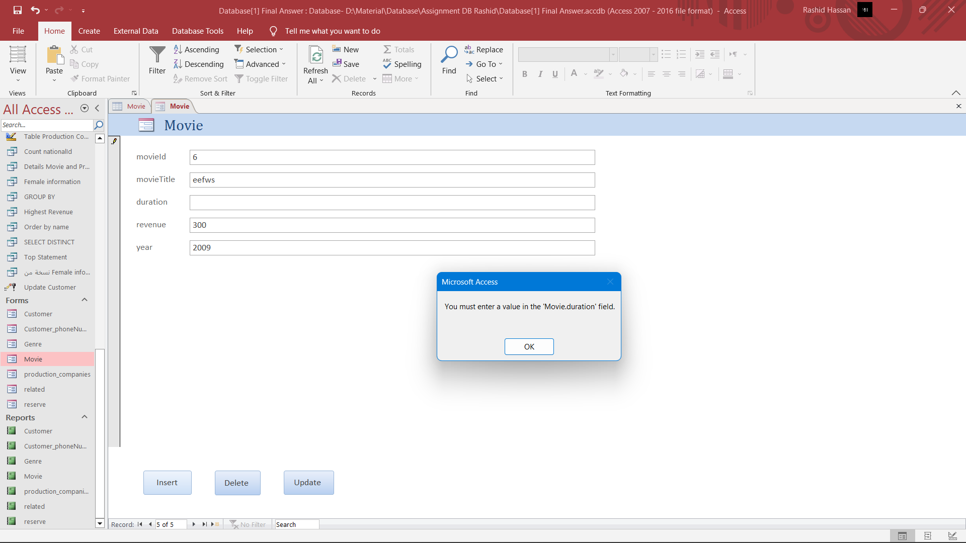

- Customer Table:

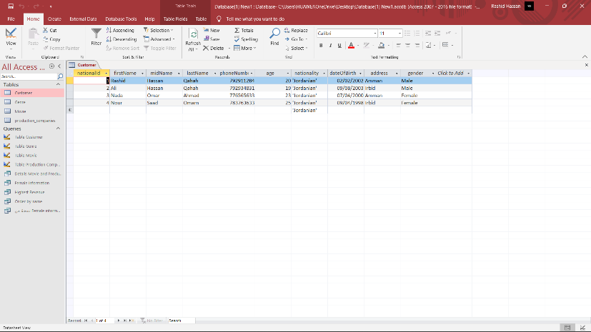

- Genre Table: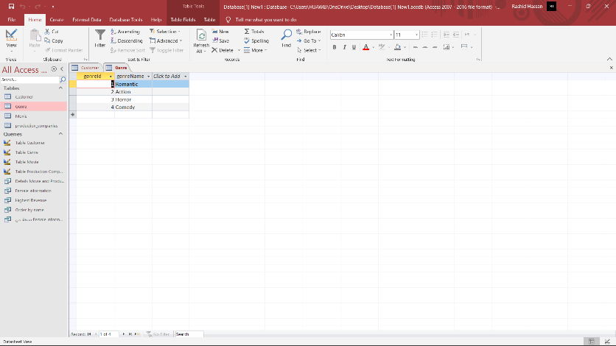

- Movie Table:

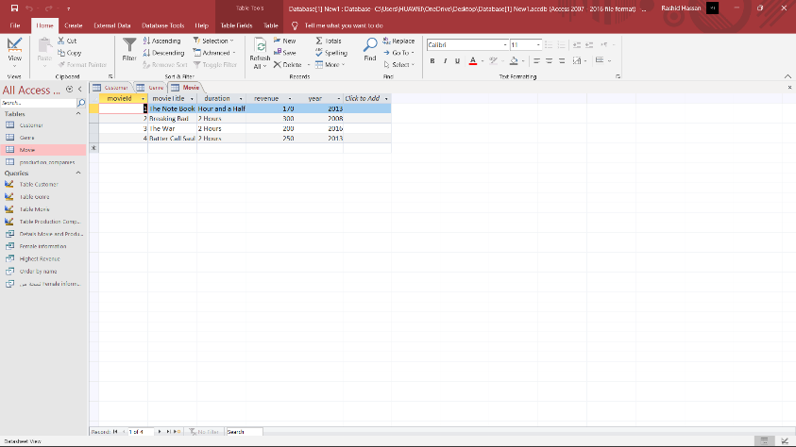

- Production Companies Table:

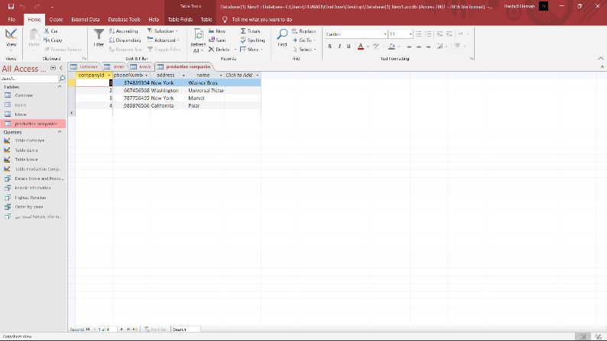

create table Customer_phoneNumber(

phoneNumber_ varchar,

nationalID int,

CONSTRAINT fk_Customer_

FOREIGN KEY (nationalID)

REFERENCES Customer (nationalId)

);

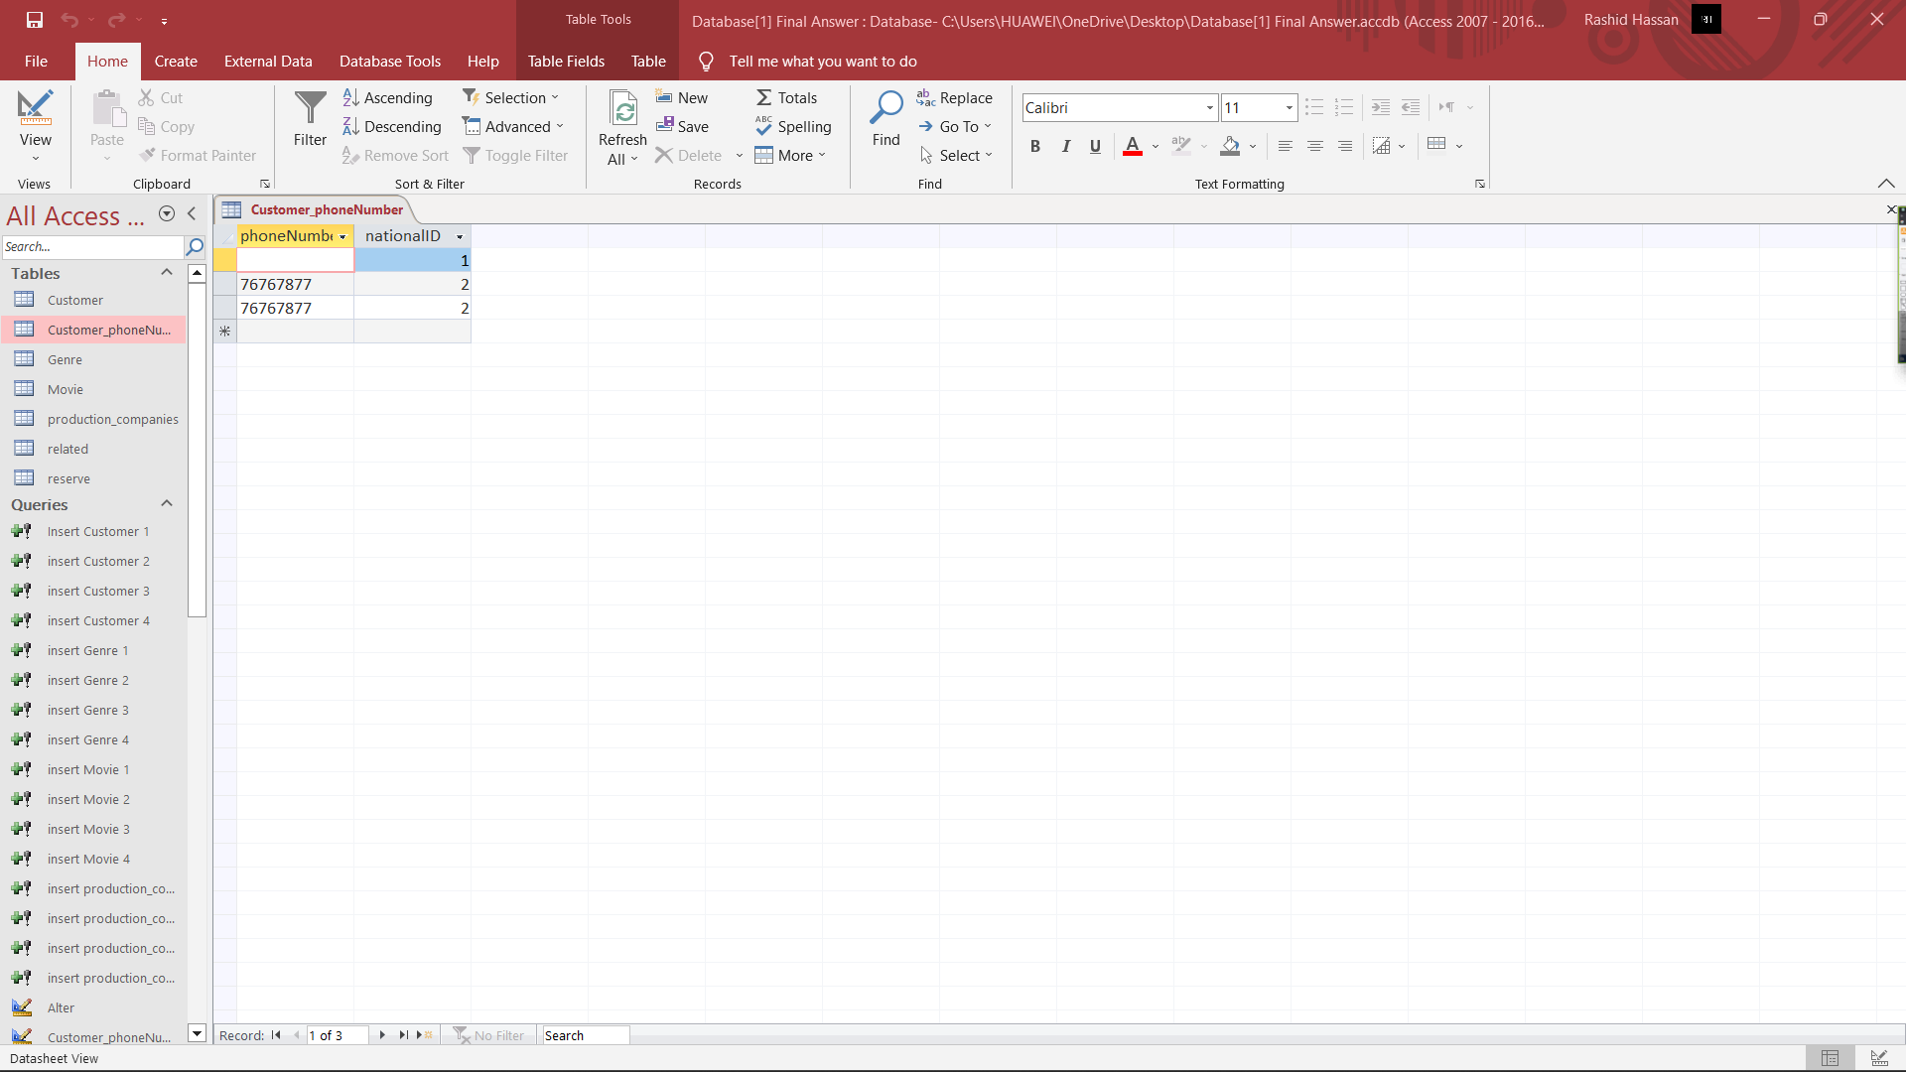

create table related(

genreID int,

movieID int,

CONSTRAINT fk_Genre

FOREIGN KEY (genreID)

REFERENCES Genre (genreId),

CONSTRAINT fk_Movie_

FOREIGN KEY (movieID)

REFERENCES Movie (movieId) );

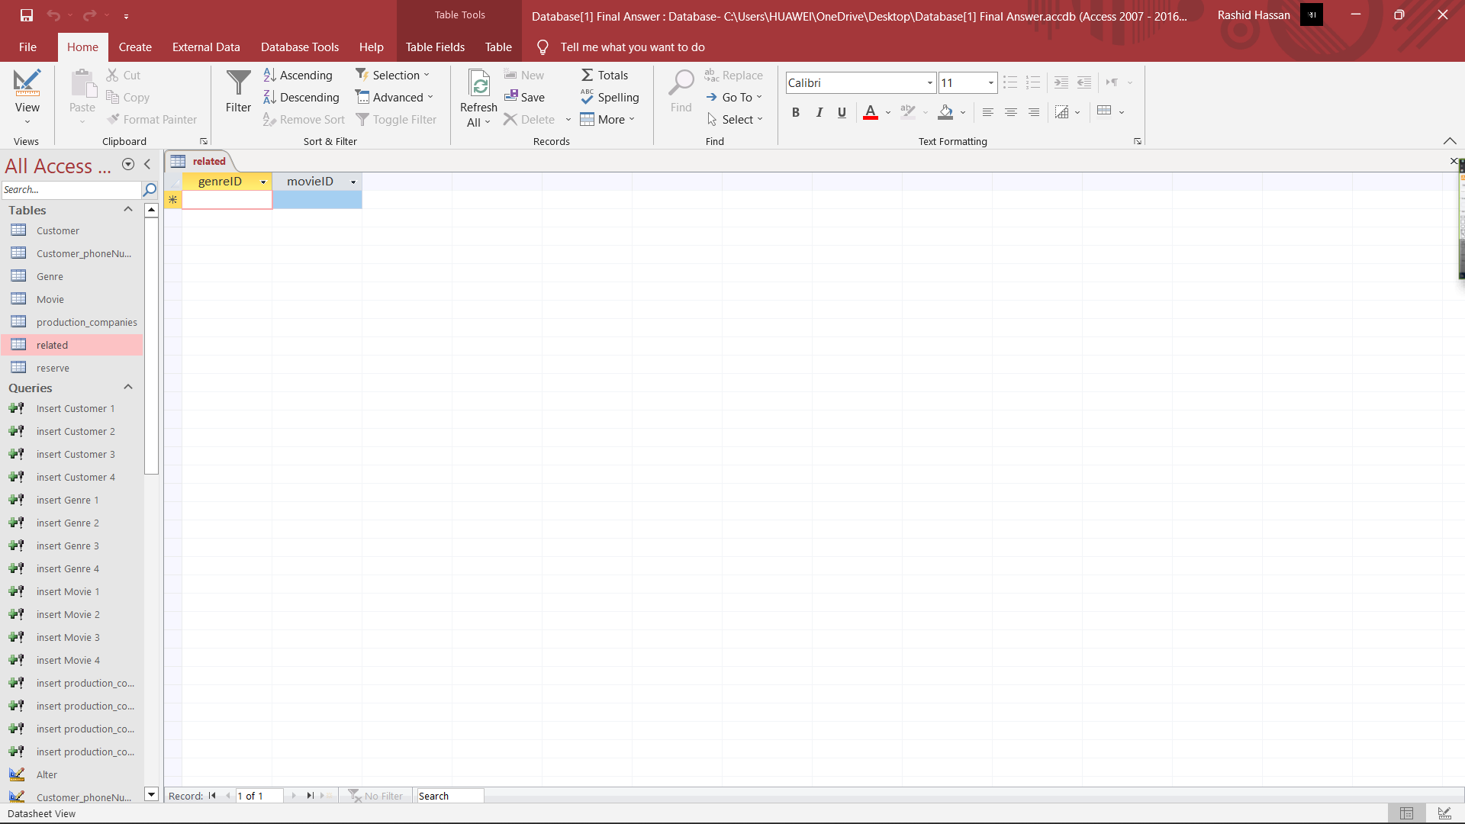

create table reserve(

nationalID int,

movID int,

CONSTRAINT fk_Customer

FOREIGN KEY (nationalID)

REFERENCES Customer (nationalId),

CONSTRAINT fk_Movie

FOREIGN KEY (movId)

REFERENCES Movie (movieId) );

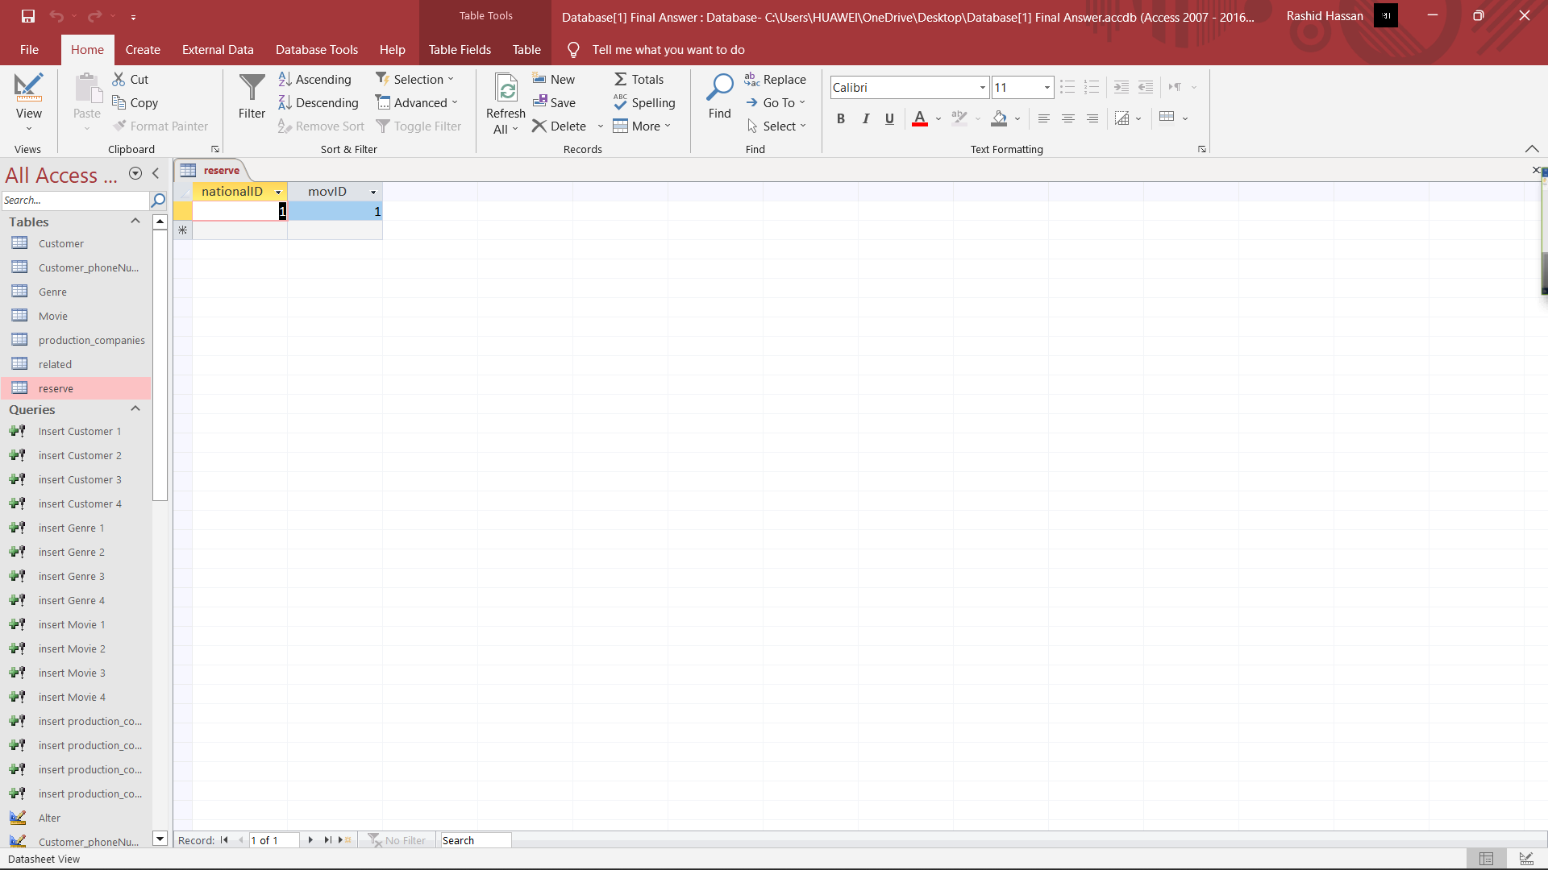

**2)**

**Answer:**

1-

SELECT nationalId, firstName,midName,lastName,phoneNumber

FROM Customer

WHERE gender = 'Female';

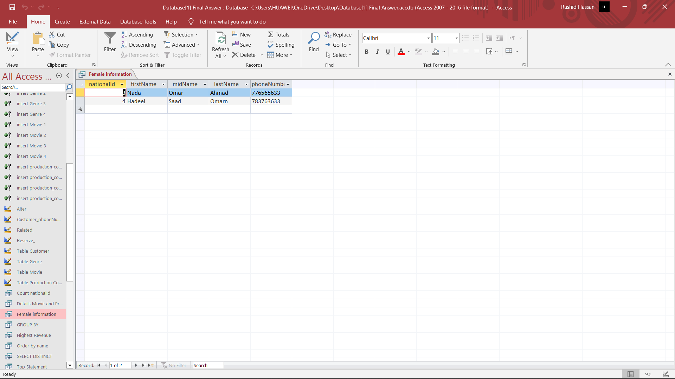

2-

SELECT name

FROM production_companies

ORDER BY name Asc;

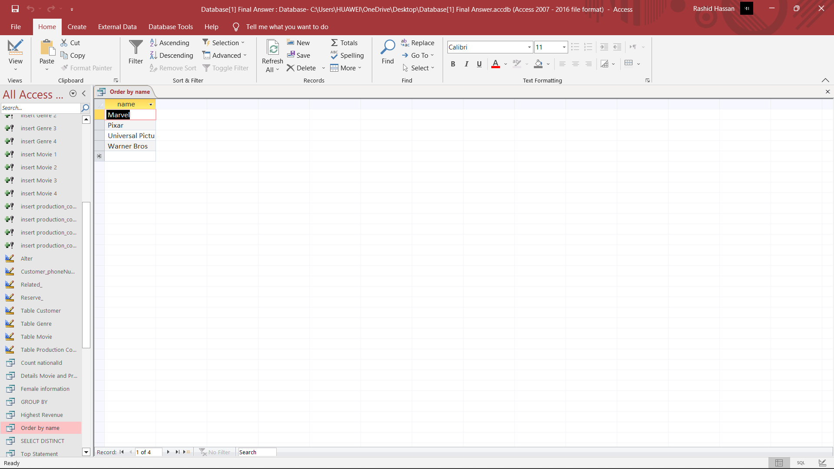

3-

SELECT Movie.movieId, Movie.movieTitle, Movie.duration, Movie.revenue, Movie.Year, Name, production_companies.phoneNumber

FROM Movie, production_companies;

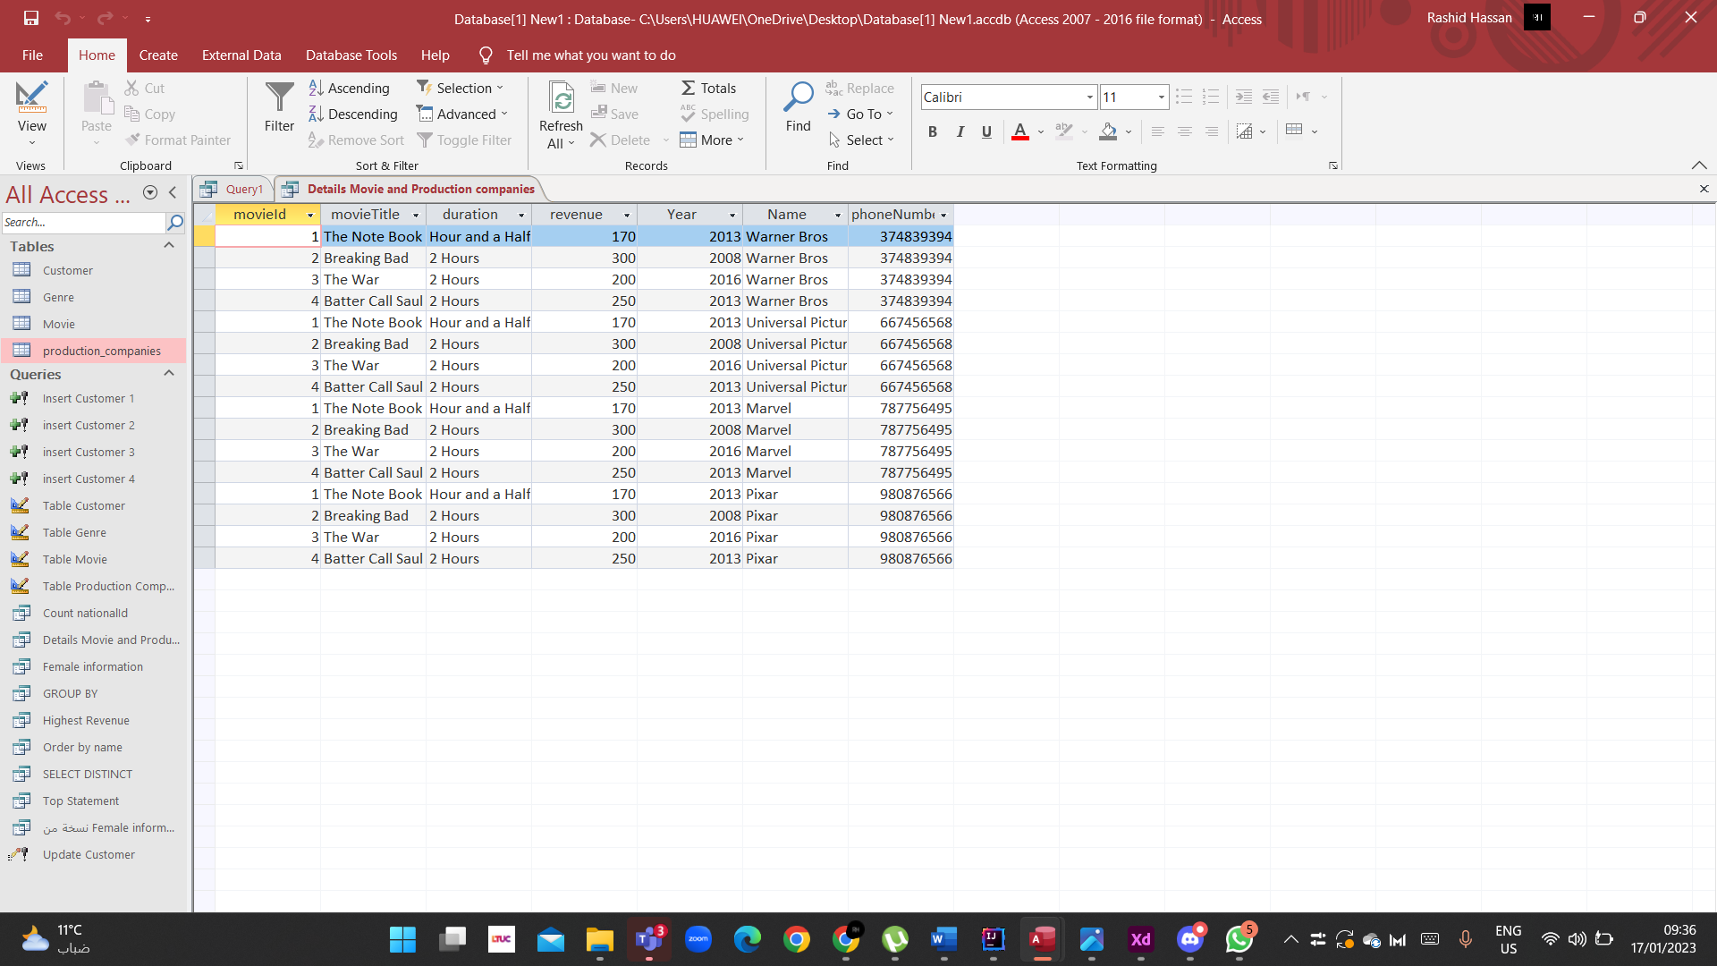

4-

SELECT max(revenue) AS Highest

FROM Movie;

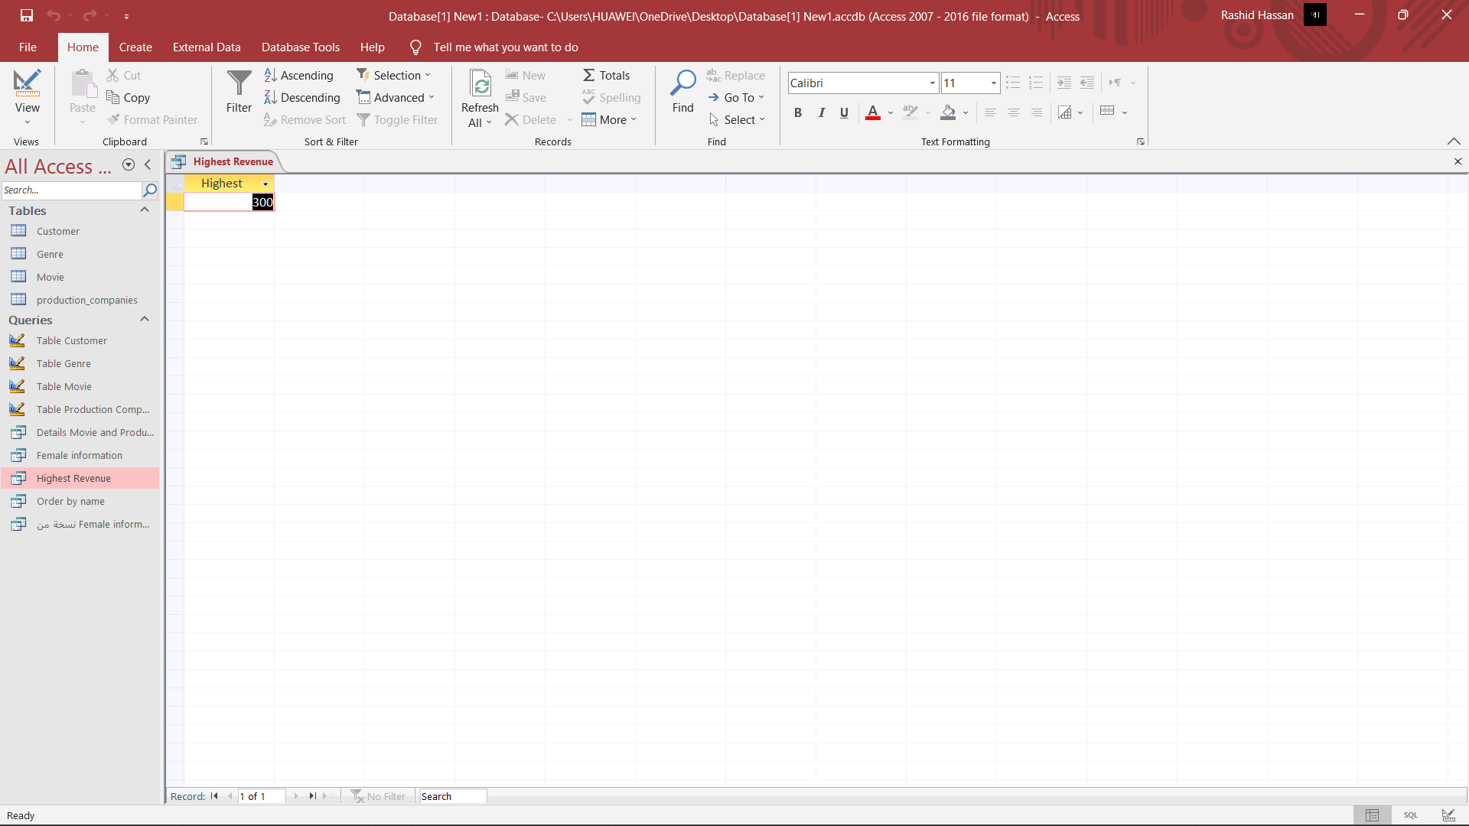

**3)**

## 1- The SQL UPDATE Statement:

UPDATE Customer SET firstName = 'Hadeel', address = 'Irbid'

WHERE nationalId = 4;

Explain:

This code is written in and it is used to update data in a database. Specifically, it updates the "firstName" and "address" fields of the "Customer" table, setting the "firstName" field to "Hadeel" and the "address" field to "Irbid" for the record where the "nationalId" field has the value of 4.

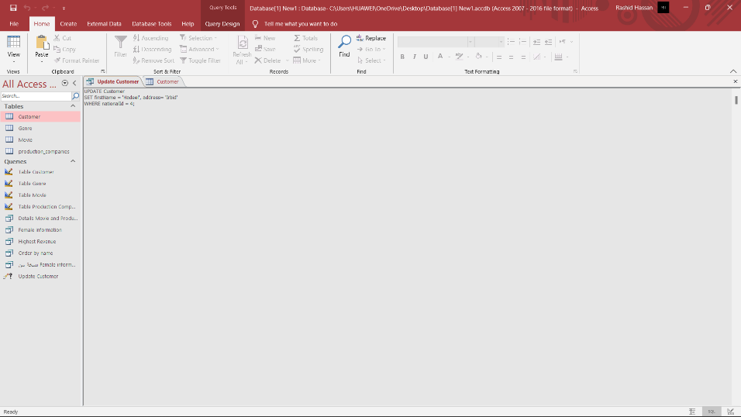

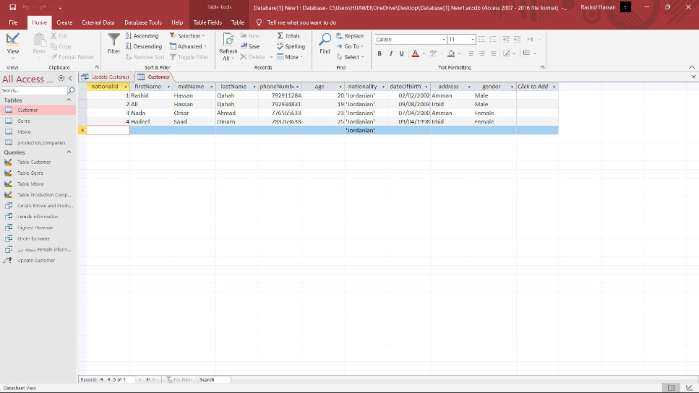

## 2- The SQL COUNT() Functions

SELECT COUNT(nationalId) AS [Count]

FROM Customer;

Explain:

This code is written in and it is used to retrieve data from a database. Specifically, it performs a SELECT statement which retrieves the count of the "nationalId" field from the "Customer" table. This count is returned as a column labeled "Count" in the results.

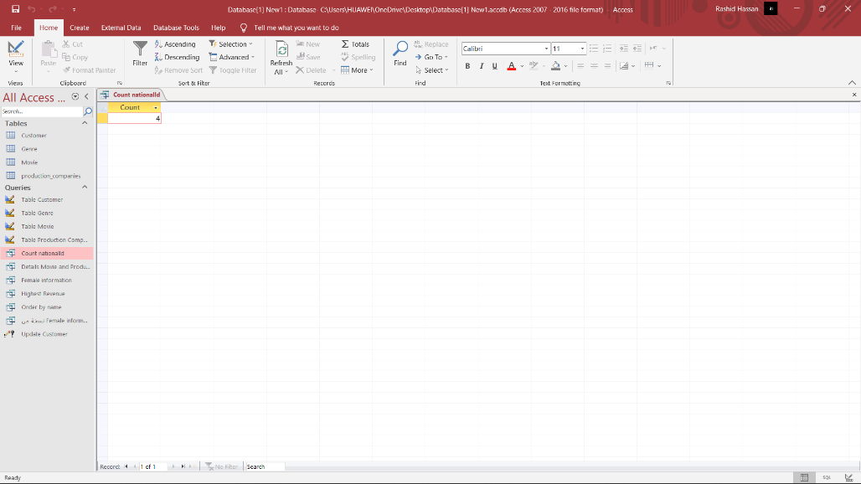

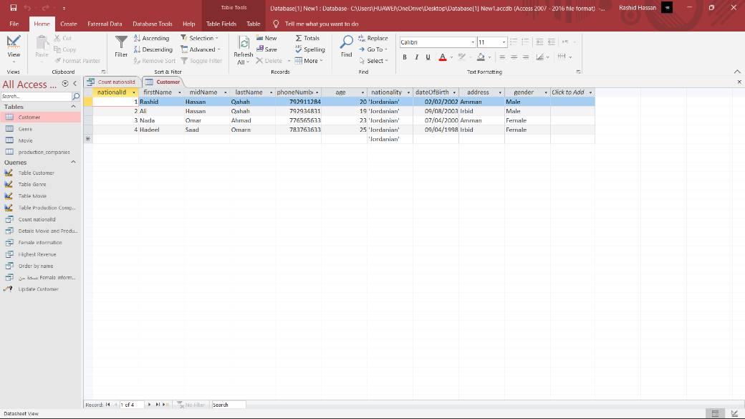

## 3- The SQL GROUP BY Statement:

SELECT COUNT(movieTitle) As ID, year As GROUP_BY

FROM Movie

GROUP BY year;

Explain:

This code is written in the code is selecting the count of the column "movieTitle" and renaming it as "ID", and the column "year" and renaming it as "GROUP_BY" from the table "Movie". It is then grouping the results by the "year" column.

The result of this query will be a table containing the count of movie titles for each year and the year that the count is for.

## 

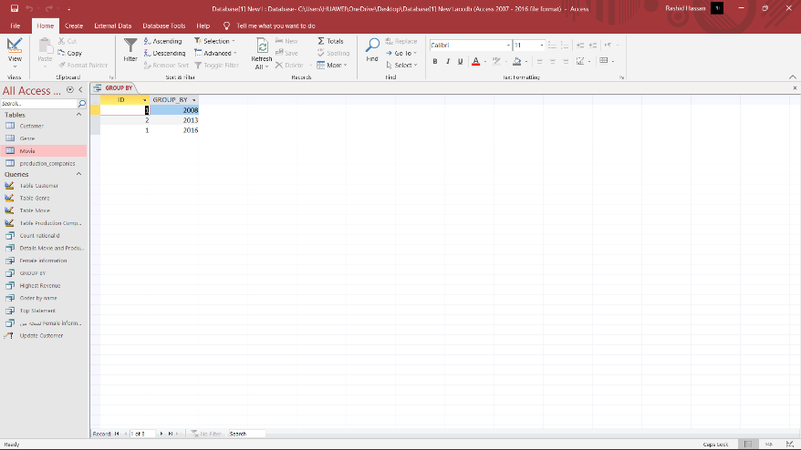

## 4- The SQL SELECT TOP Clause:

SELECT TOP 2 *

FROM Customer;

Explain:

This code is written in the code is selecting the top 2 rows from the "Customer" table, and returning all columns of those rows.

The result of this query will be a table containing the top 2 rows of the "Customer" table.

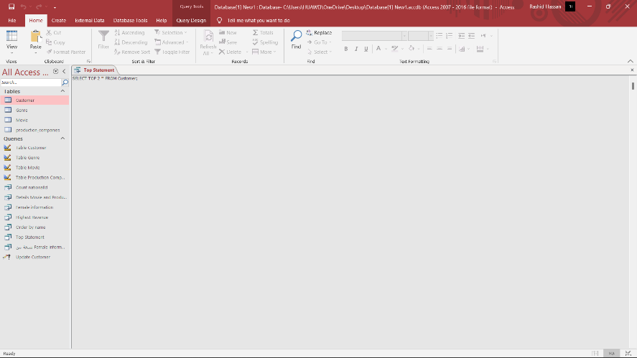

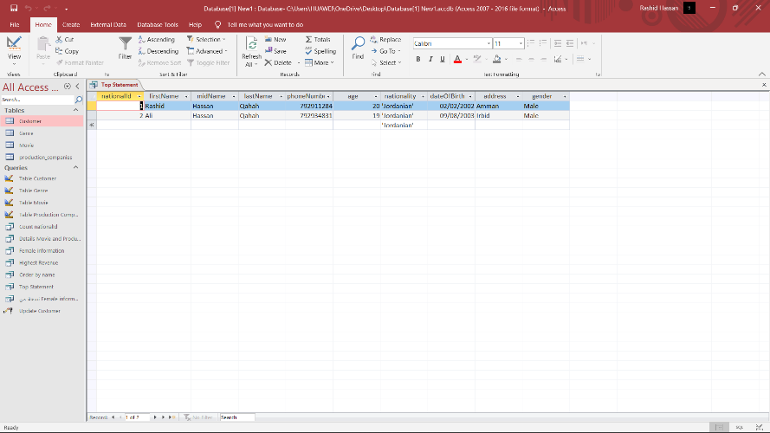

## 5- The SQL SELECT DISTINCT Statement:

SELECT DISTINCT name FROM production_companies;

Explain:

This code is written in the code is selecting the distinct values of the "name" column from the "production_companies" table. The DISTINCT keyword is used to return only unique values from the column. The result of this query will be a table containing unique names of the production companies.

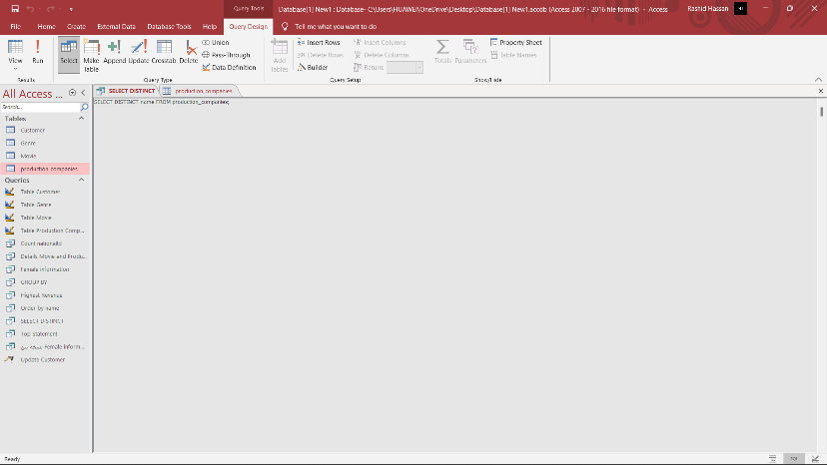

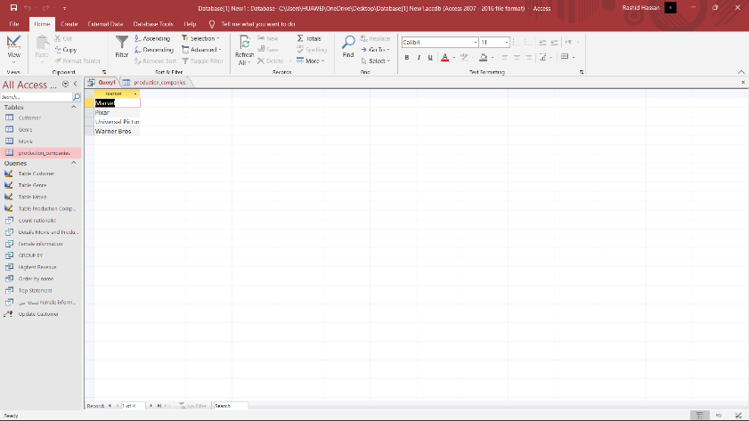

4.Create simple interfaces to insert, update and delete data in the database, for each entity

- Input, Update, Delete, Output Report Information:

- Production companies Table:

I entered the company ID 5, I also entered the phone number 62723823, I also entered the address, which is Tabuk, and finally I entered the name RCV, and pressed Insert, after that he added it to the table as the producing company.

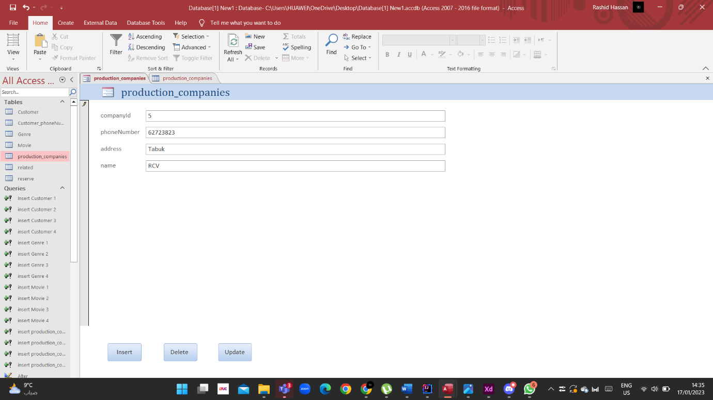

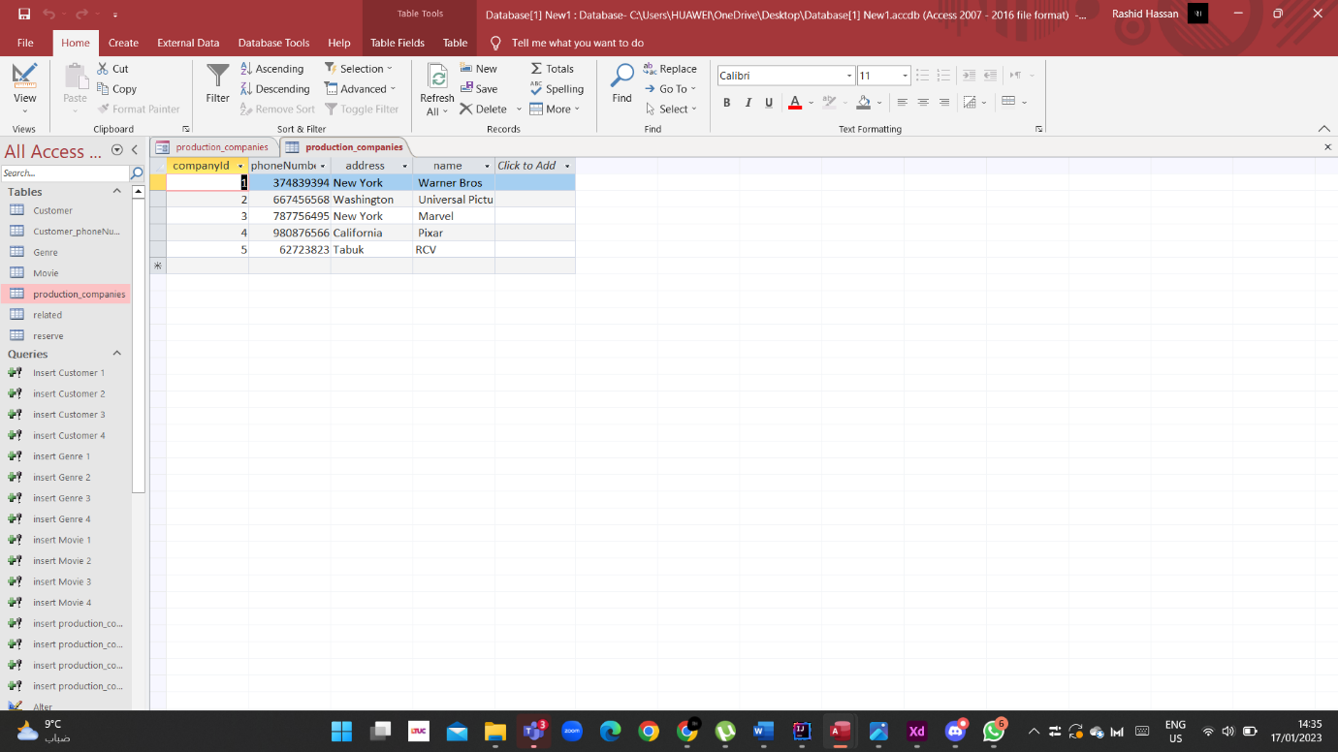

I entered Company ID 6 to update the information and kept the rest of the information as it is, then pressed Update.

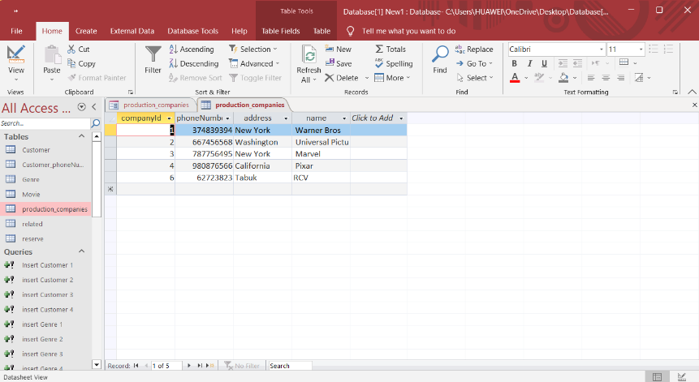

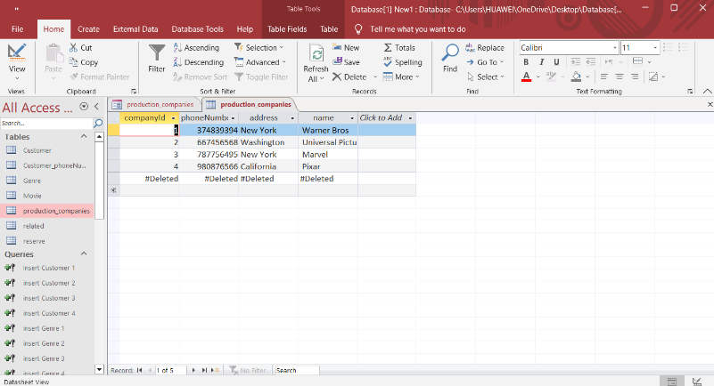

Finally, I pressed Delete to delete the information that you entered recently.

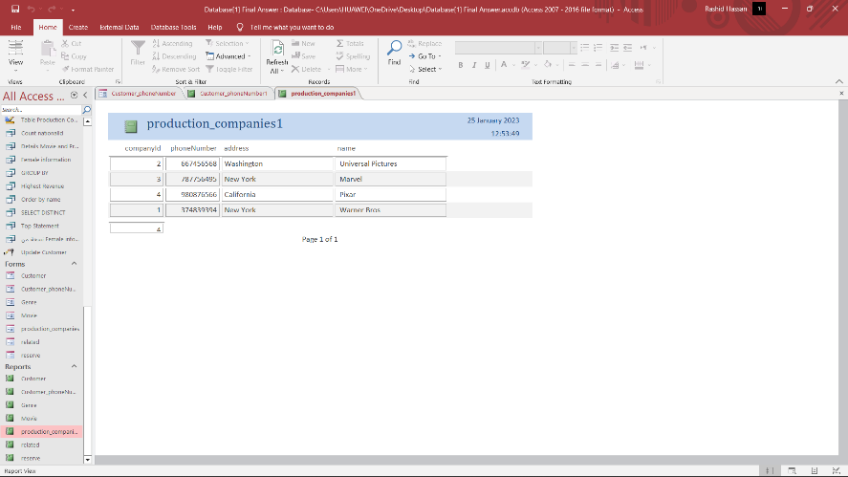

The report for the table of the producing company, in which the data is organized and presented in a specific format, in which the information and history of the operations that you performed appear.

- Input, Update, Delete, Output Report Information:

- Customer Table:

We have entered the information of a new customer and we want to add him to the table after we have entered all his information, which is (National ID, Name, Mid name, Last name, phone number, Birth date, Gender, Address, Nationality, age). Then we click on Insert.

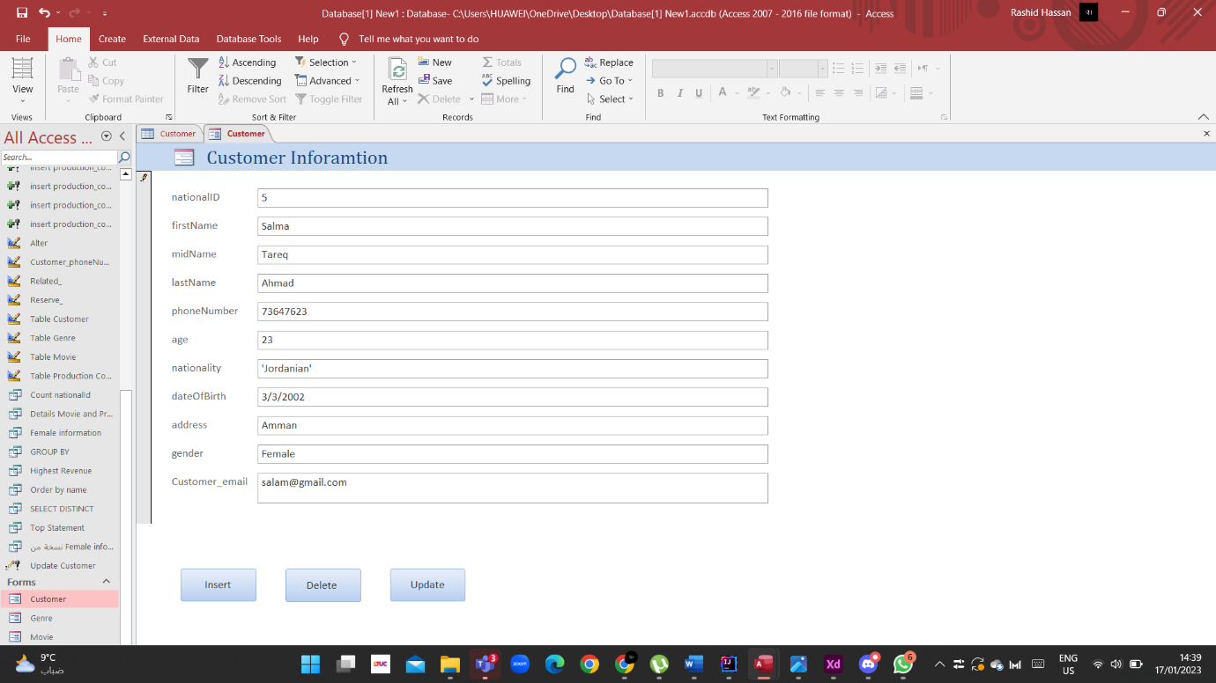

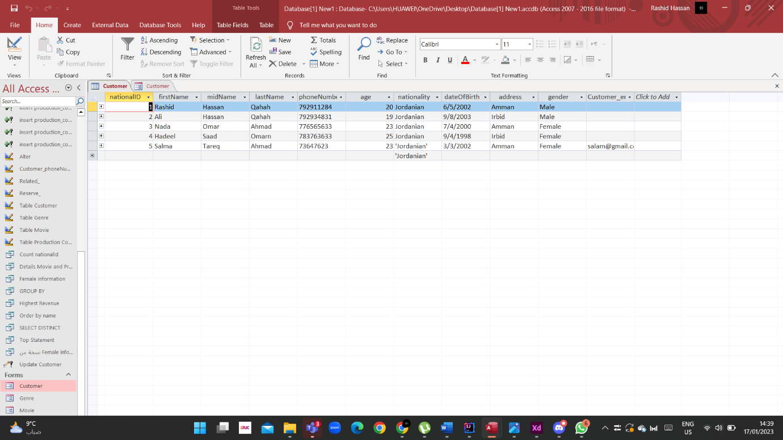

I entered national Id 6 to update the information and kept the rest of the information as it is, then pressed Update.

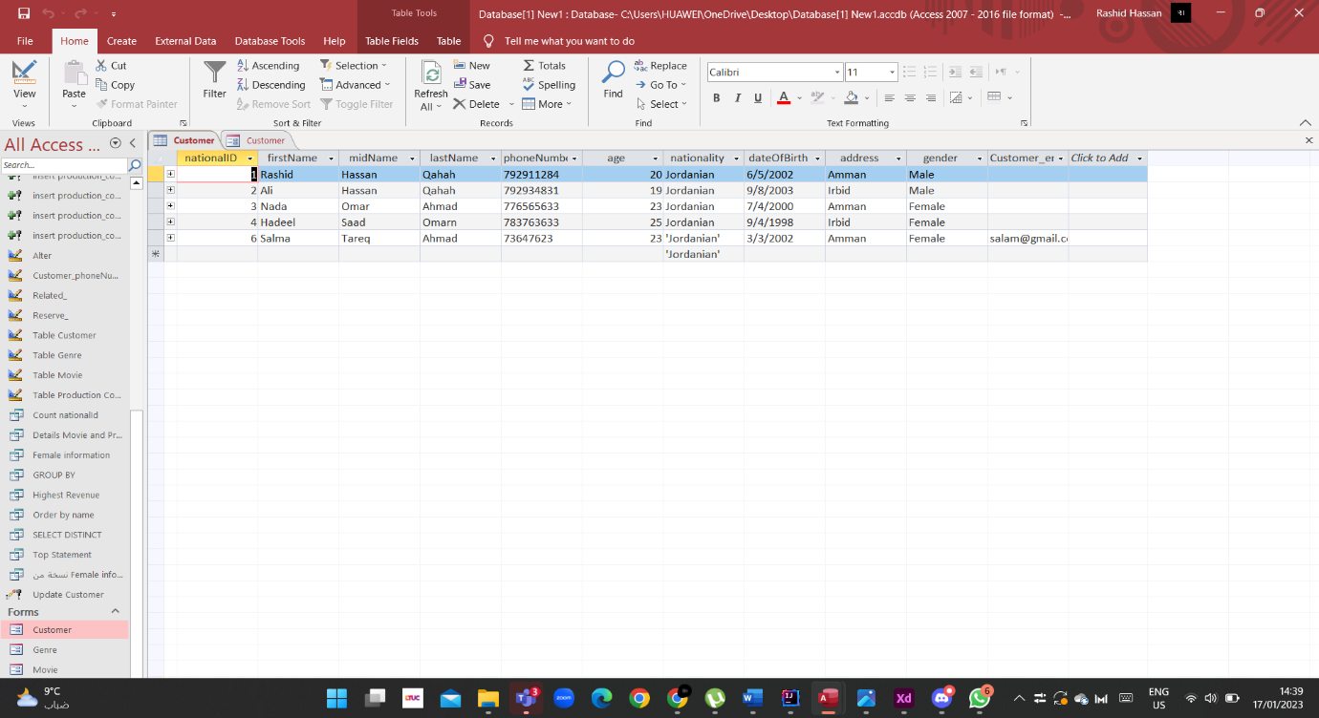

Finally, I pressed Delete to delete the information that you entered recently.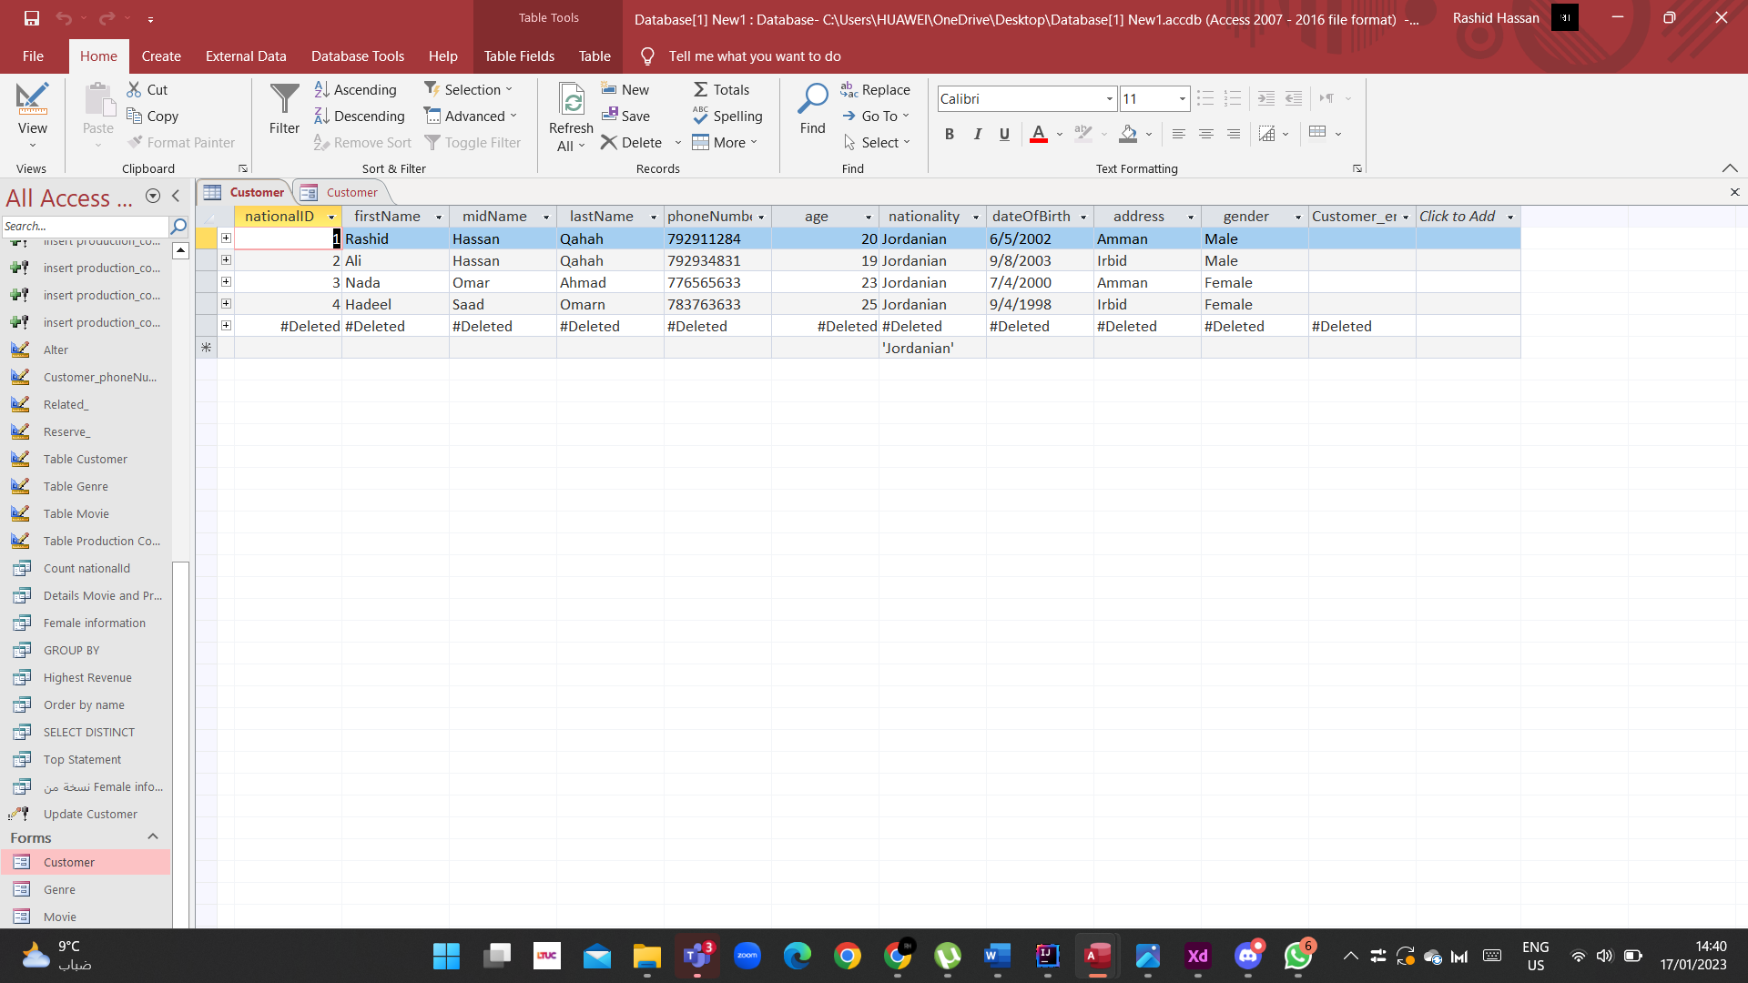

The report for the table of the Customer Table, in which the data is organized and presented in a specific format, in which the information and history of the operations that you performed appear.

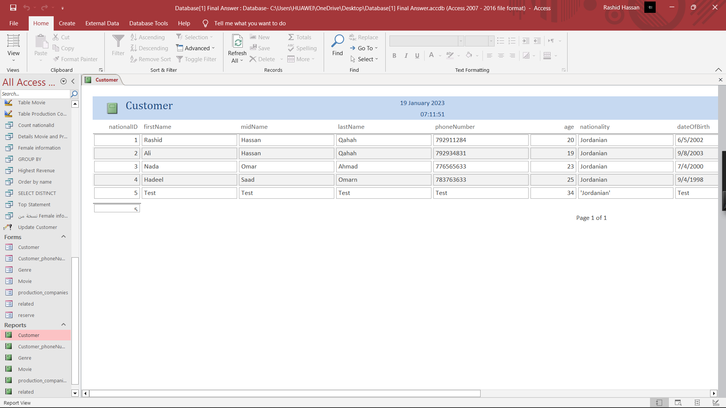

- Input, Update, Delete, Output Report Information:

- Movie Table:

We have entered the information of a new Movie and we want to add him to the table after we have (Movie id, Movie title, year, duration, revenue). entered all his information, which is Then we click on Insert.

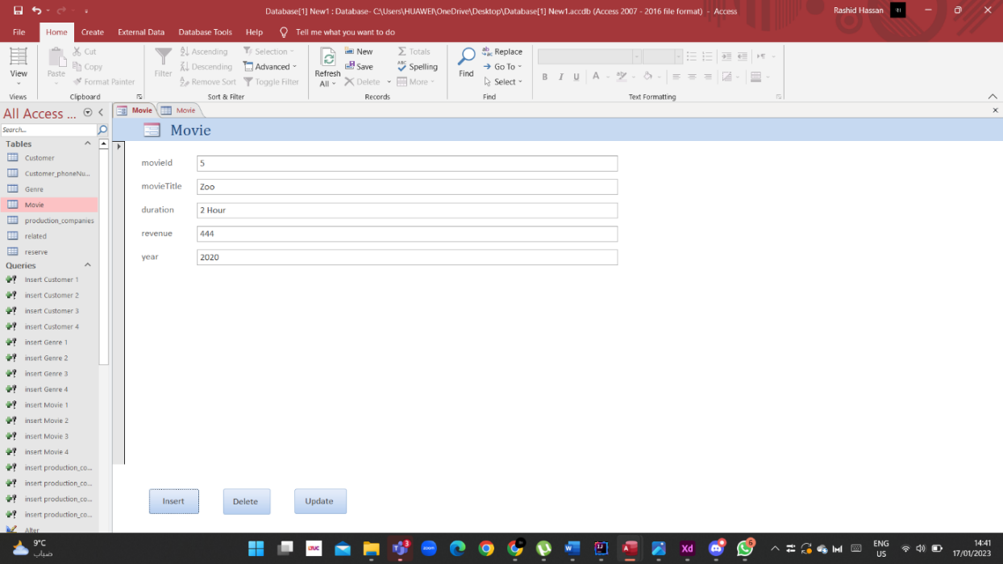

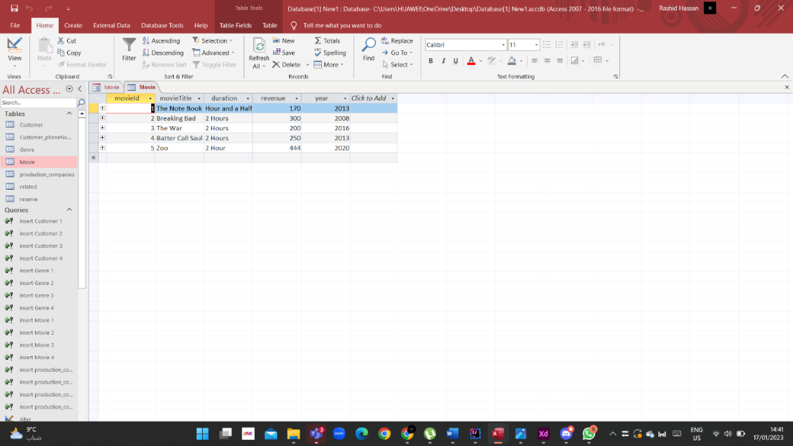

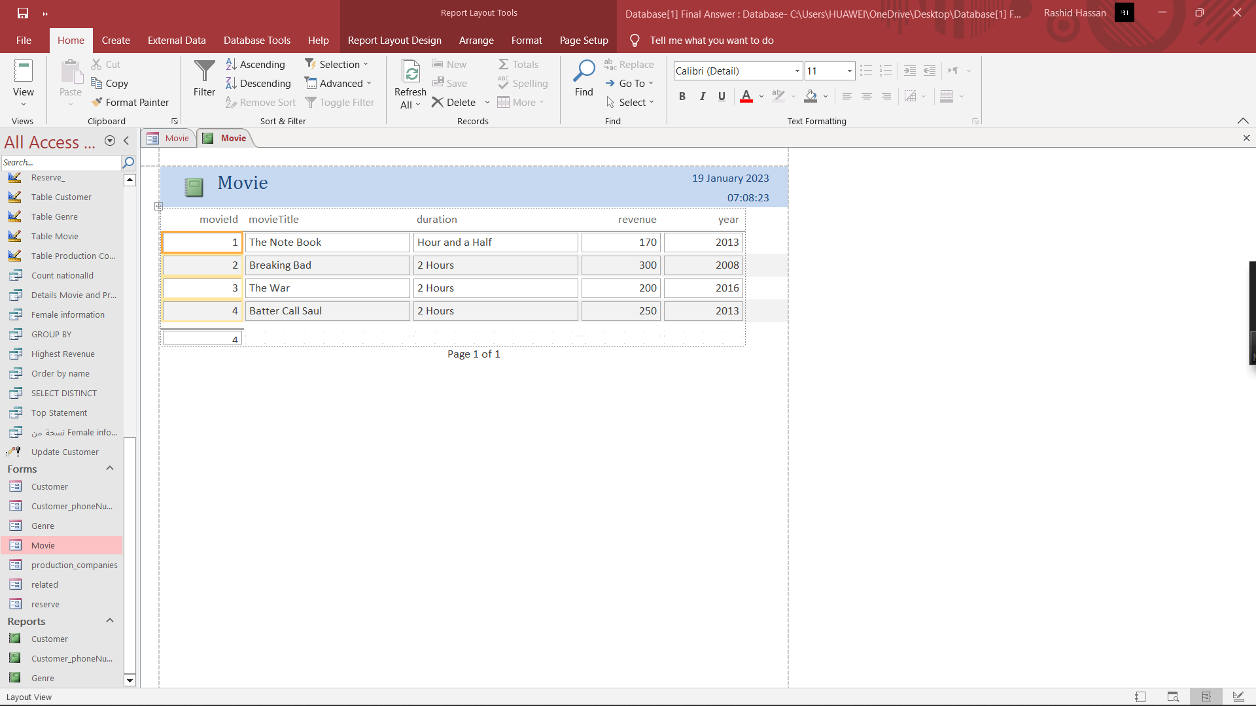

The report for the table of the Movie Table, in which the data is organized and presented in a specific format, in which the information and history of the operations that you performed appear.

I entered movie Id 7 to update the information and kept the rest of the information as it is, then pressed Update.

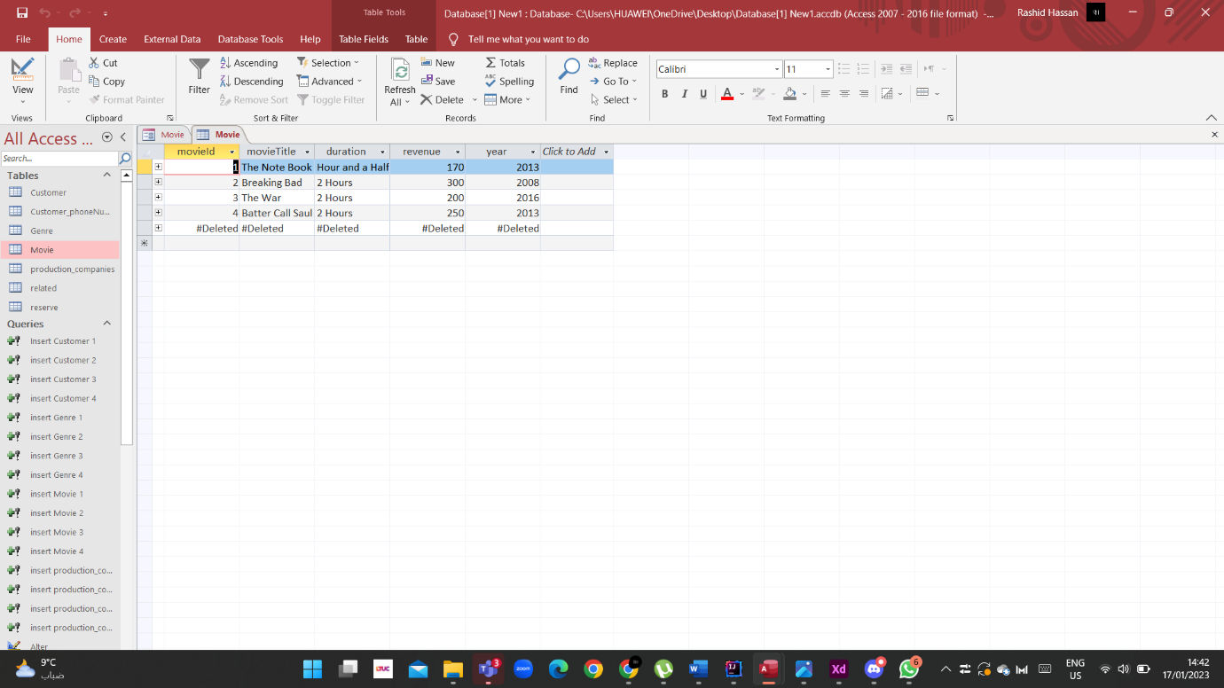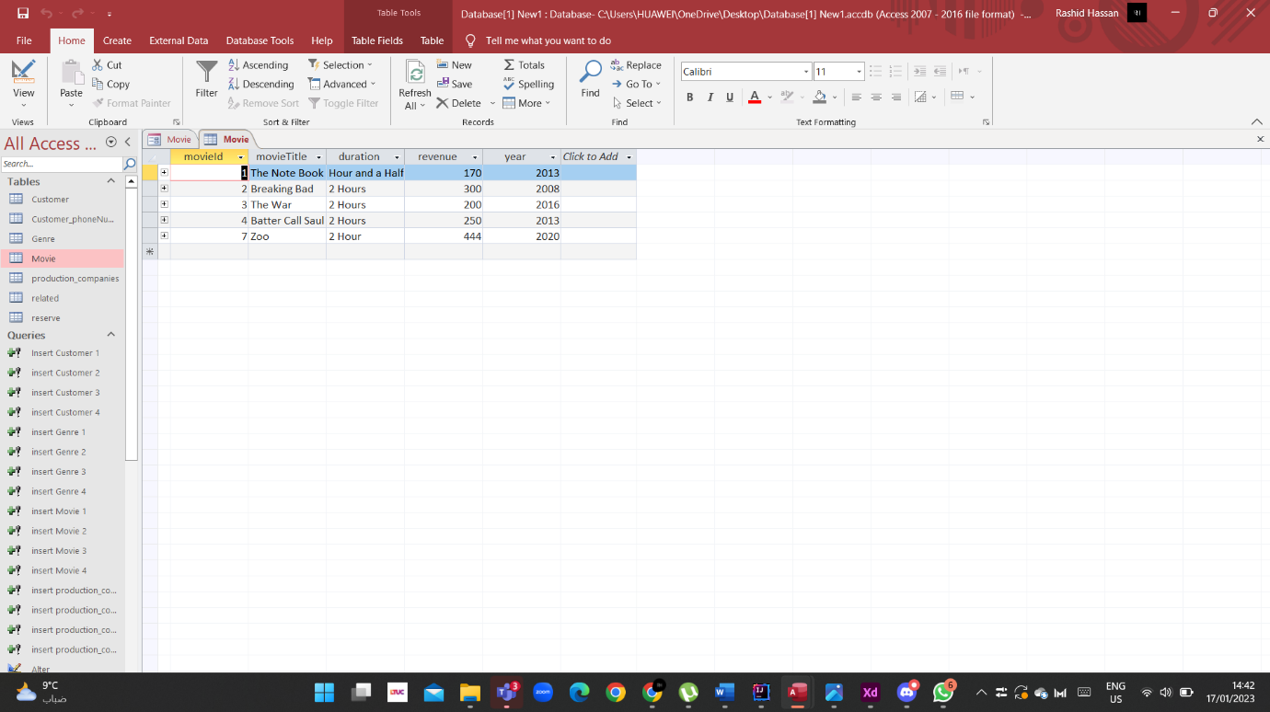

Finally, I pressed Delete to delete the information that you entered recently.

- Input, Update, Delete, Output Report Information:

- Genre Table:

We have entered the information of a new Genre and we want to add him to the table after we have (genre id, genre name). entered all his information, which is Then we click on Insert.

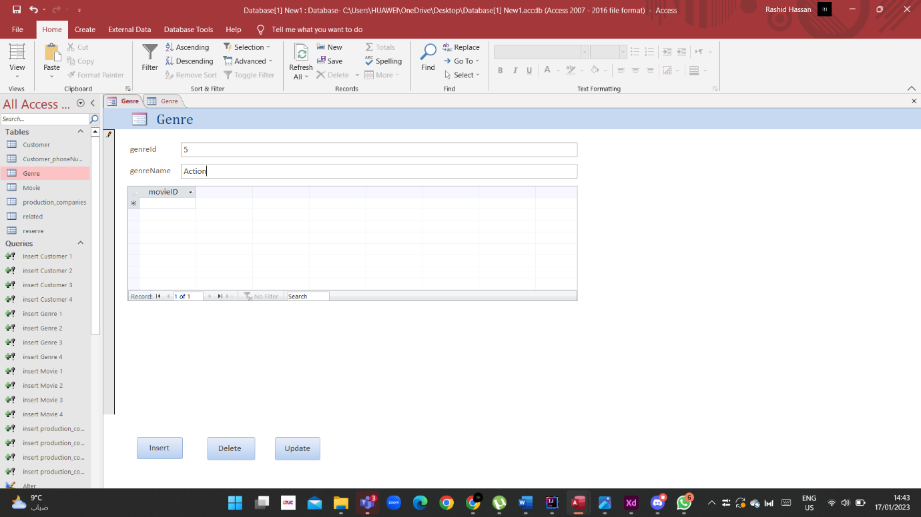

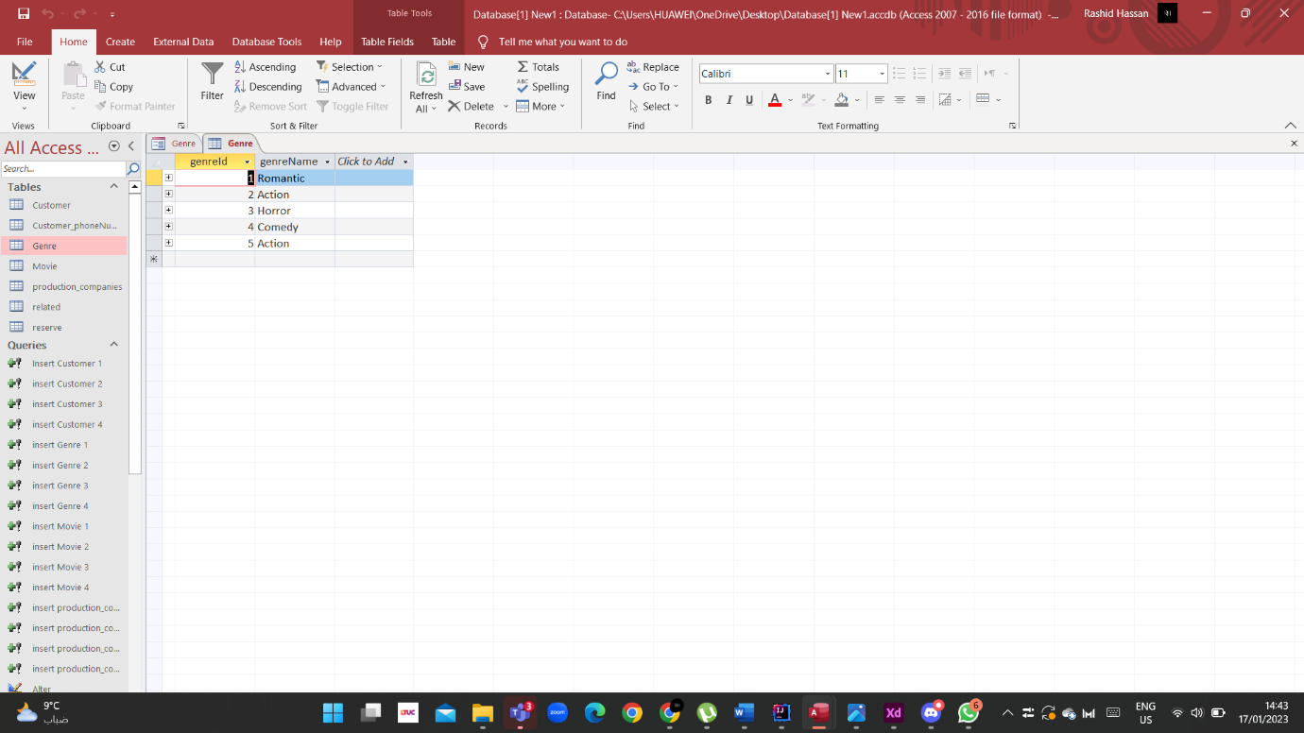

I entered genre Id 6 to update the information and kept the rest of the information as it is, then pressed Update.

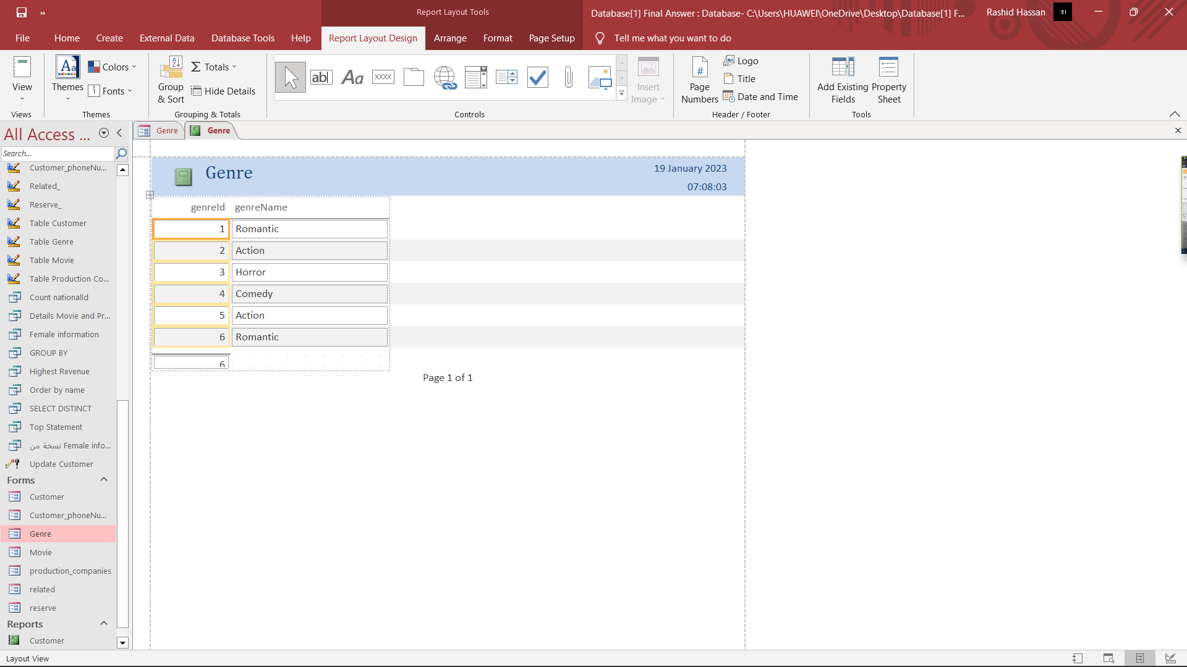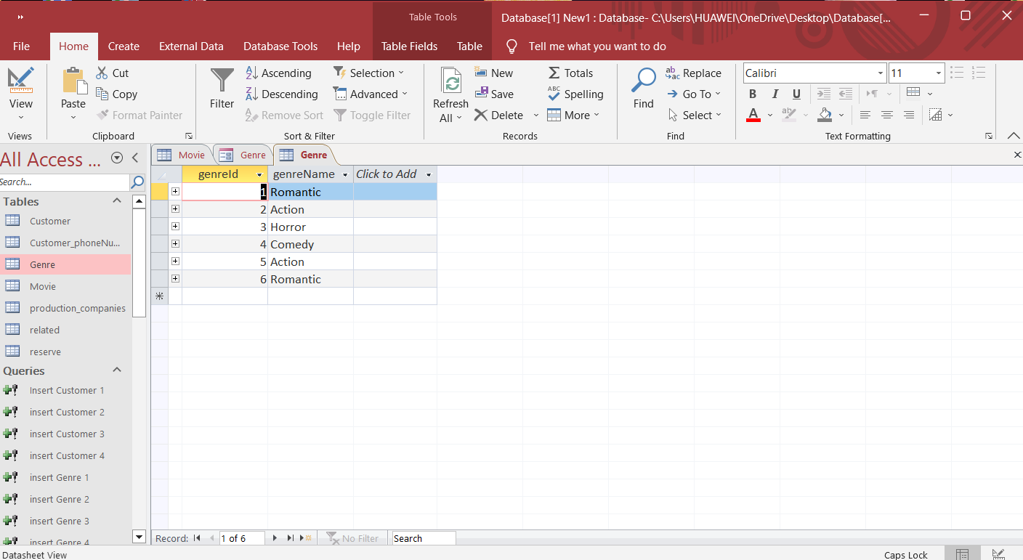The report for the table of the Genre Table, in which the data is organized and presented in a specific format, in which the information and history of the operations that you performed appear.

- Input, Update, Delete, Output Report Information:

- Customer_phoneNumber Table:

Here we entered the phone number as well as the national ID, then we pressed Insert.

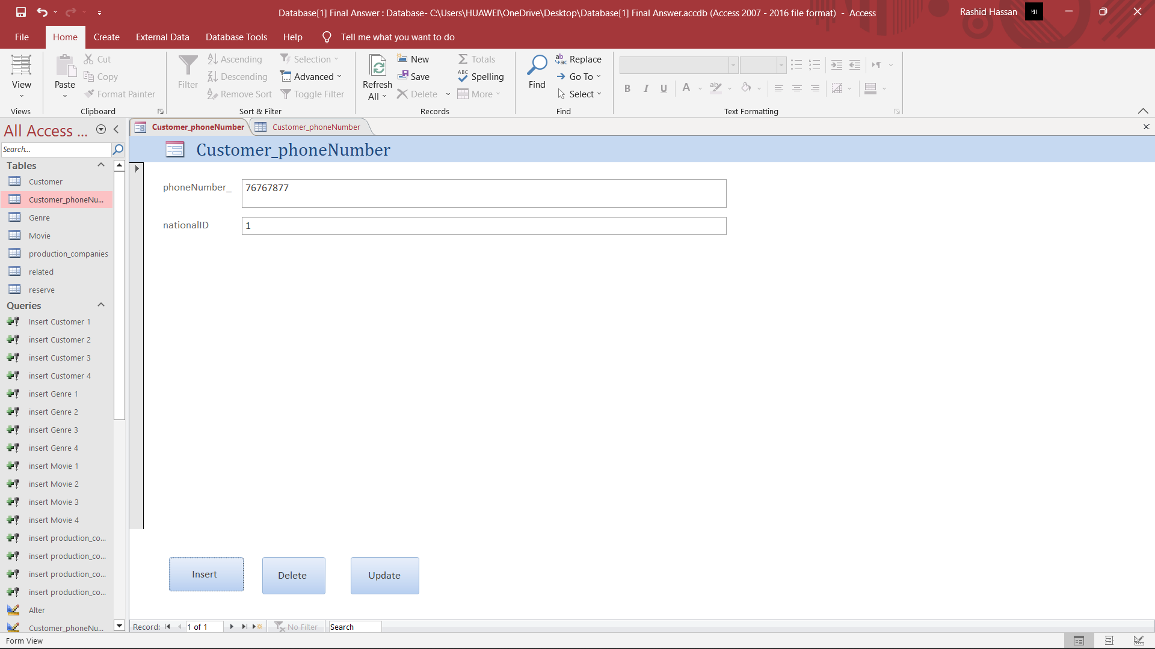

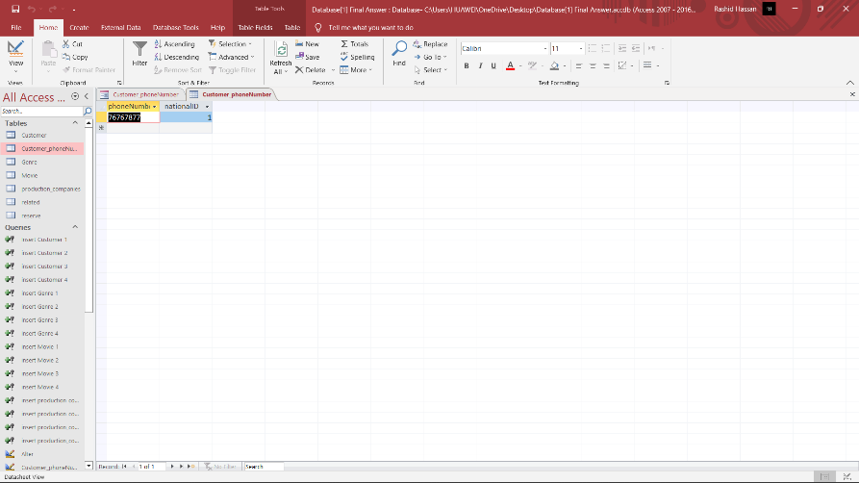

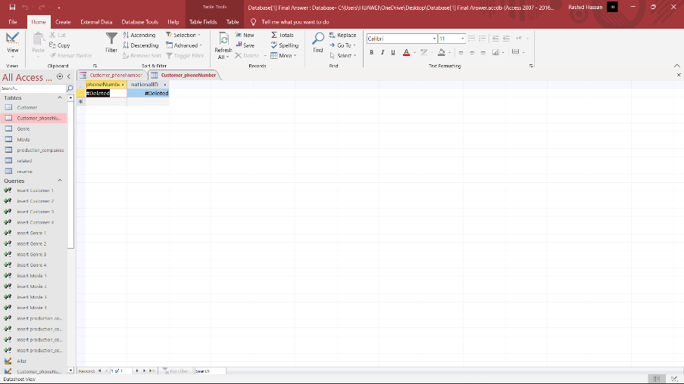

Finally, I pressed Delete to delete the information that you entered recently.

I entered National Id 7 to update the information and kept the rest of the information as it is, then pressed Update.

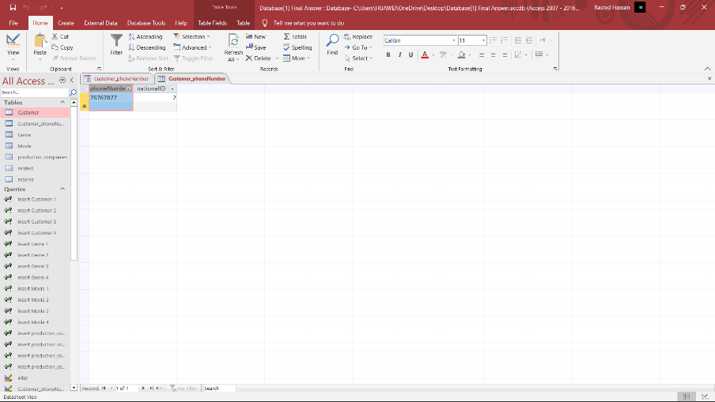

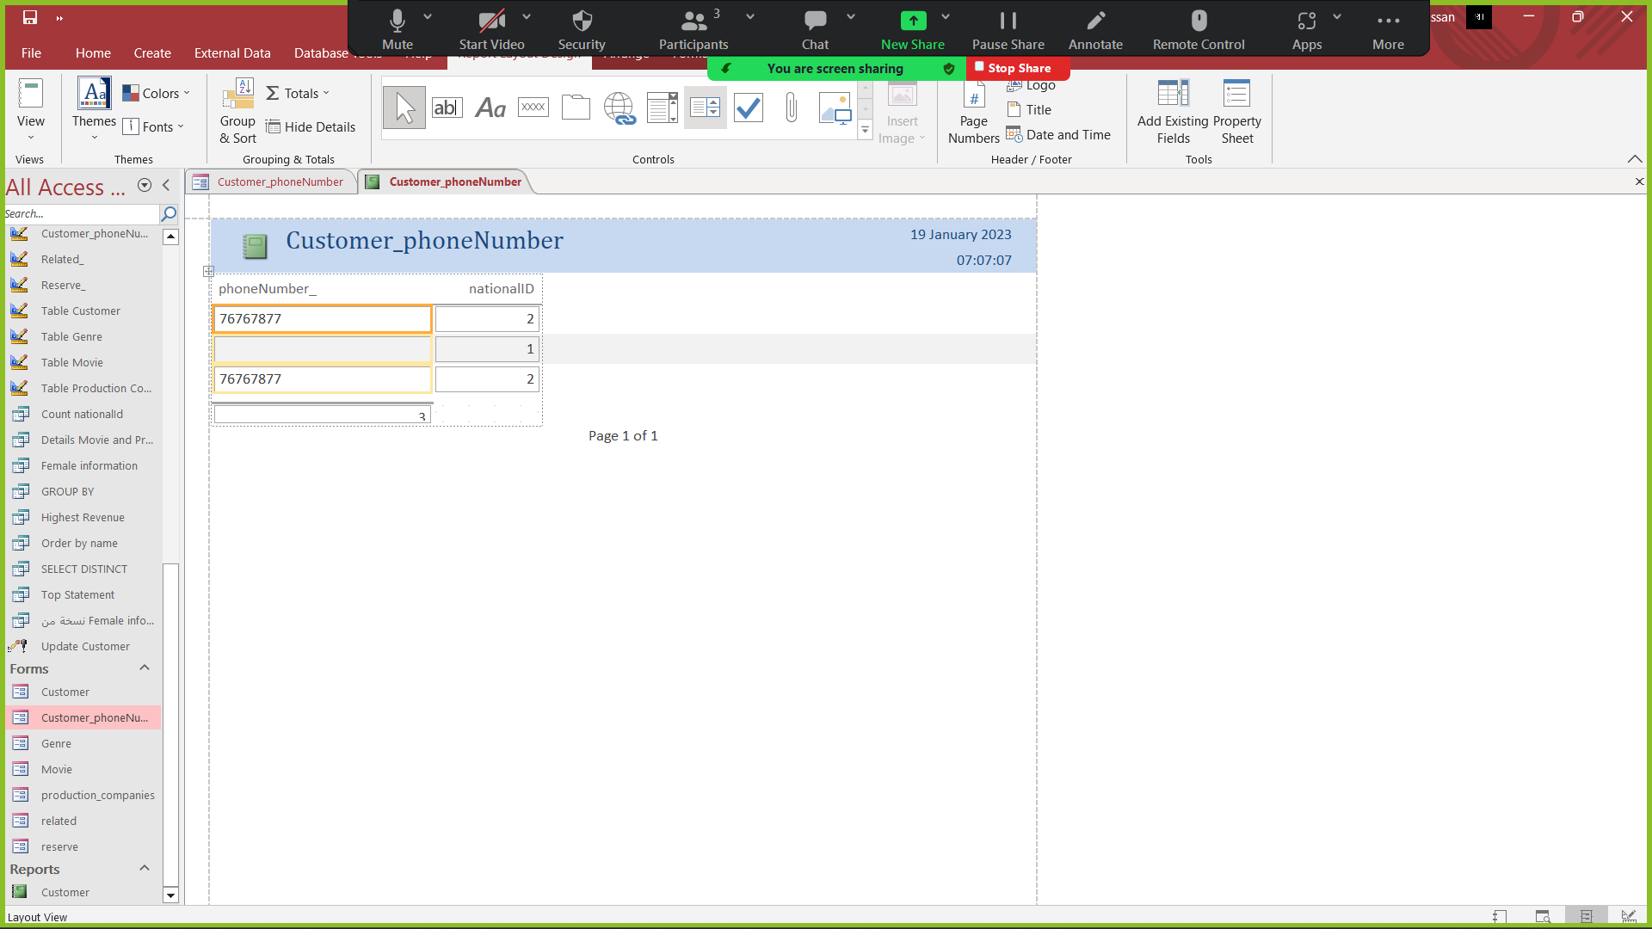

The report for the table of the Customer_phone Number Table, in which the data is organized and presented in a specific format, in which the information and history of the operations that you performed appear.

- Input, Update, Delete, Output Report Information:

- Related Table:

Here we entered the genreId as well as the movieId, then we pressed Insert.

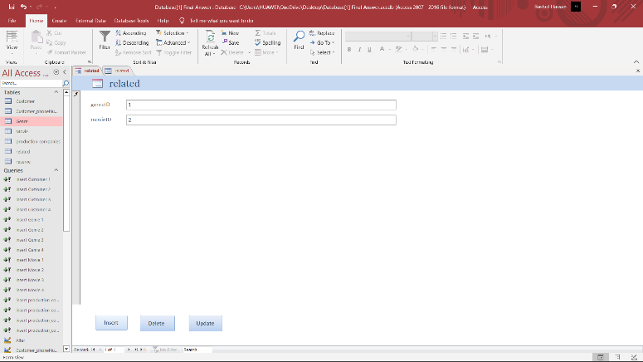

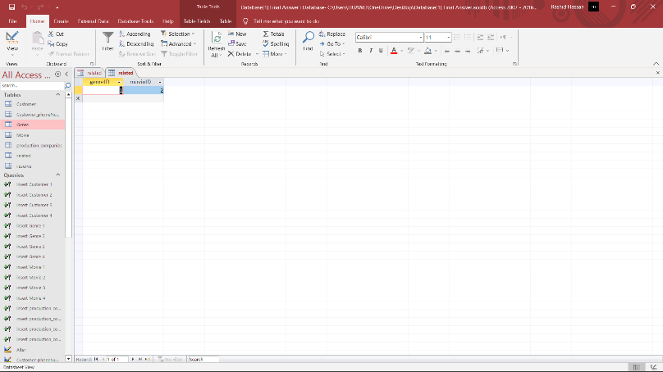

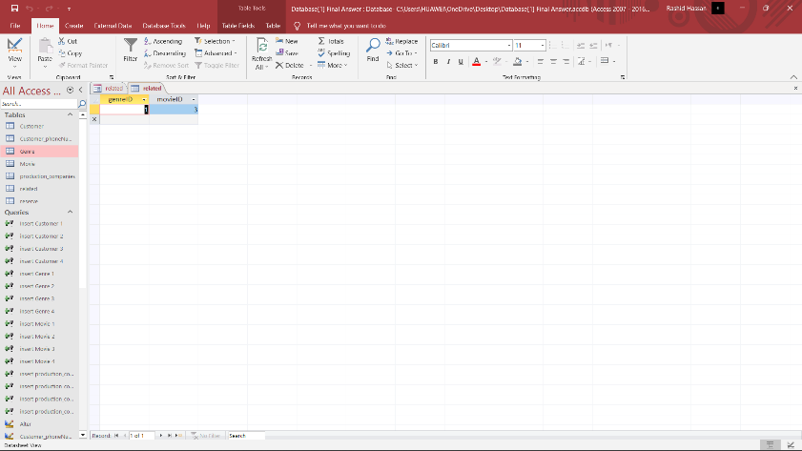

I entered movieId 3 to update the information and kept the rest of the information as it is, then pressed Update.

The report for the table of the related Table, in which the data is organized and presented in a specific format, in which the information and history of the operations that you performed appear.

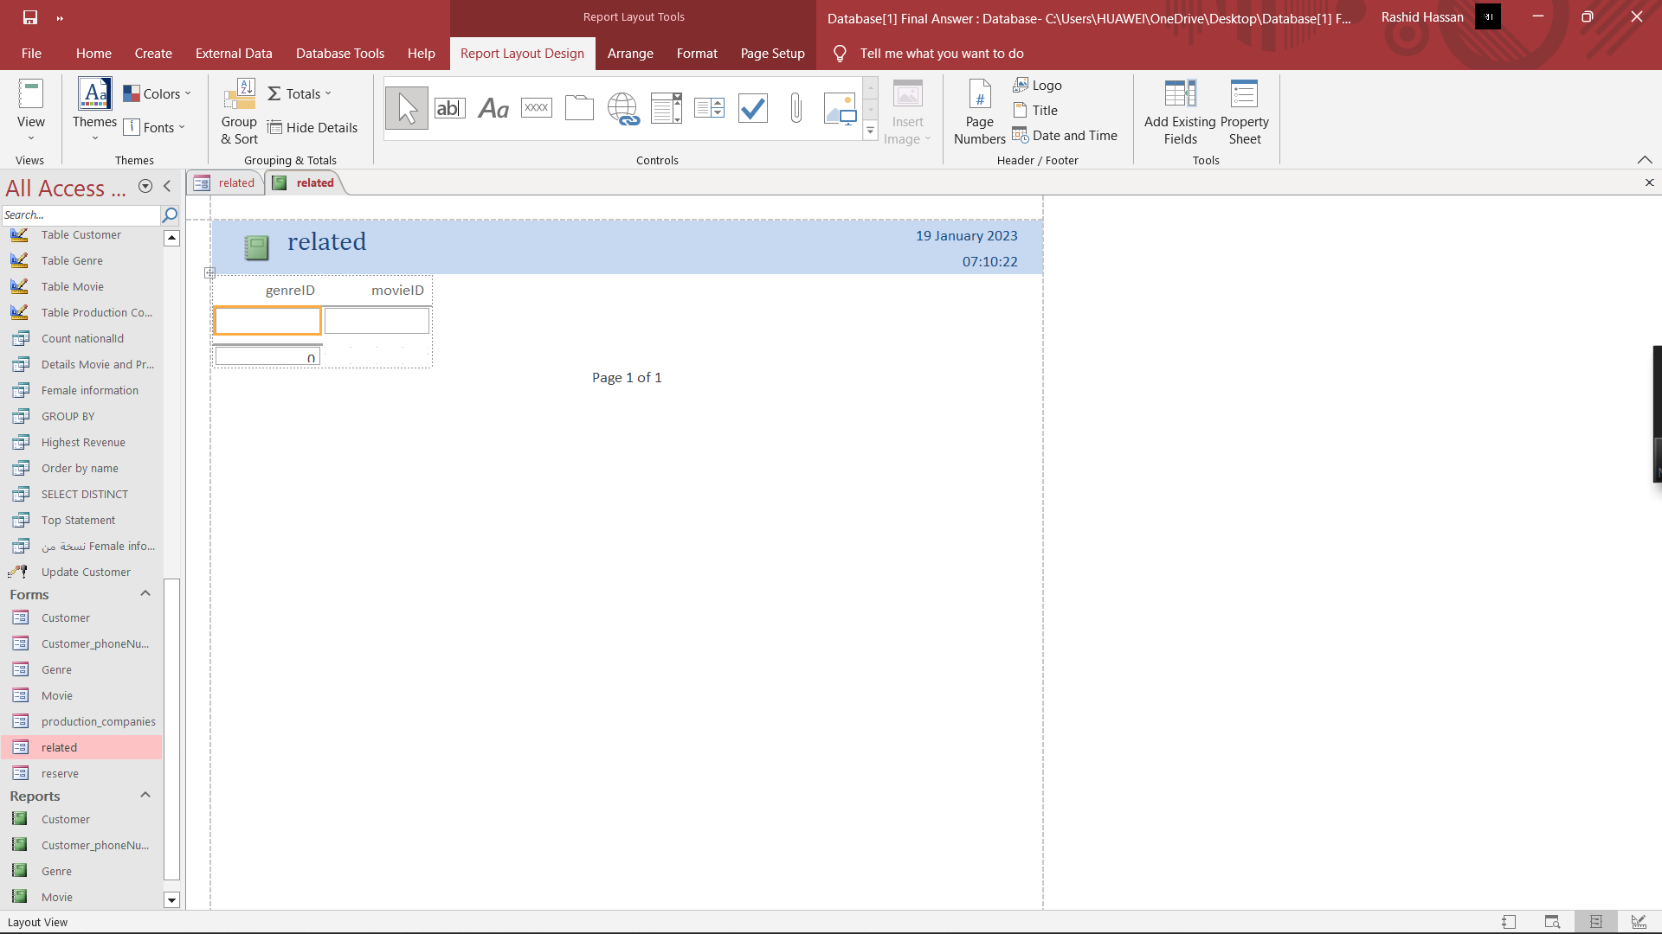

- Input, Update, Delete, Output Report Information:

- Reserve Table:

Here we entered the nationalId as well as the movieId, then we pressed Insert.

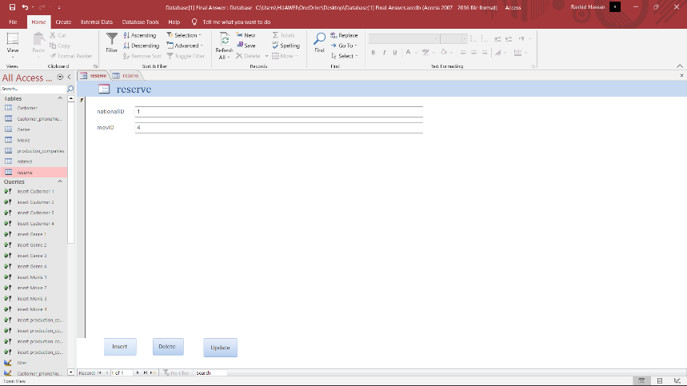

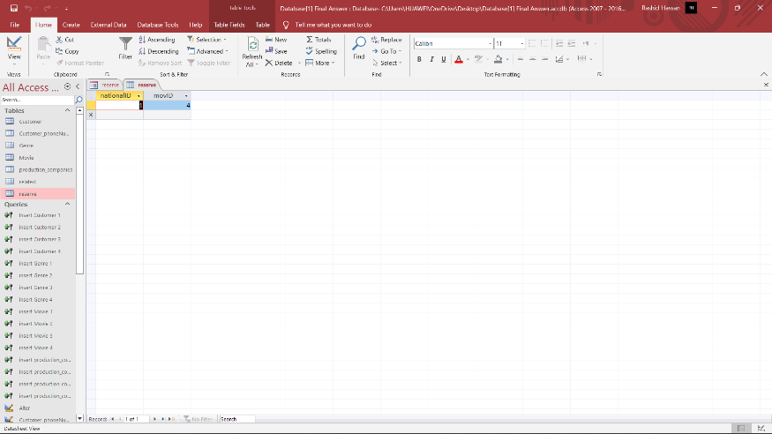

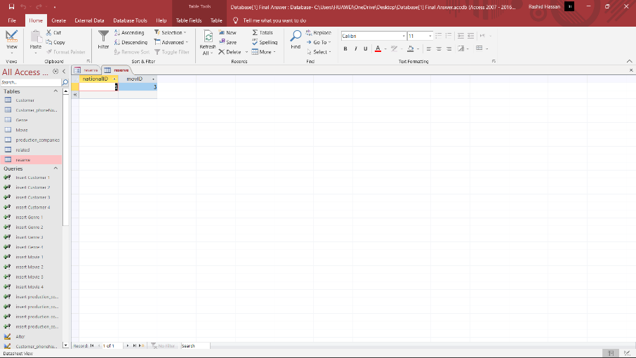

I entered movieId 3 to update the information and kept the rest of the information as it is, then pressed Update.

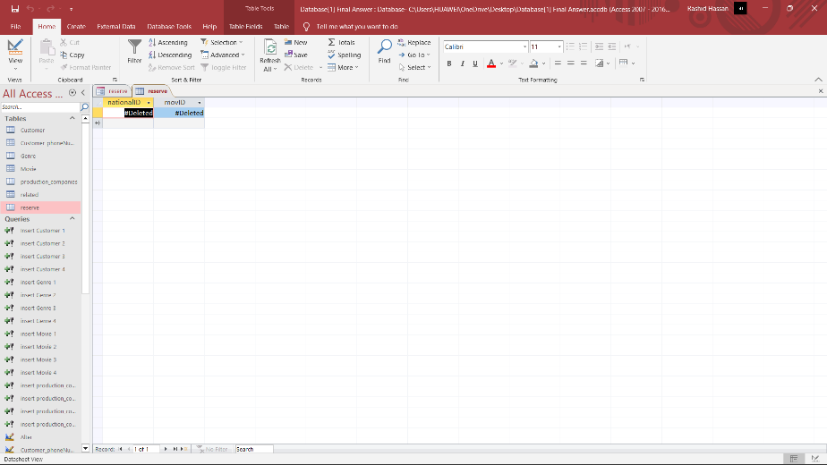

Finally, I pressed Delete to delete the information that you entered recently.

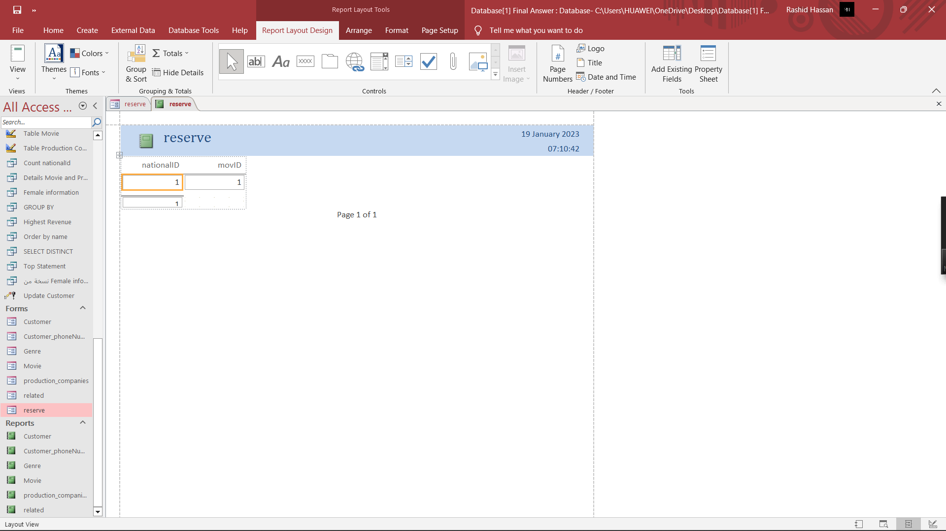

The report for the table of the reserve Table, in which the data is organized and presented in a specific format, in which the information and history of the operations that you performed appear.

You need to apply security to the implemented database by adding a strong **password.**

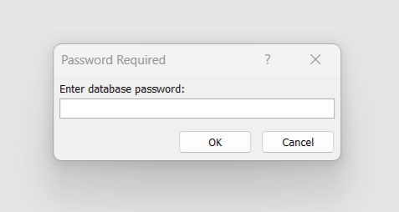

**Answer:**

**Password is (00 99 88).**

**Task 3:** Evaluating the database system

1. Based on the user and system requirements, measure the implemented database solution by listing each requirement along with where it was met and how it was achieved. In addition, recommend improvements based on the assessment

**Answer:**

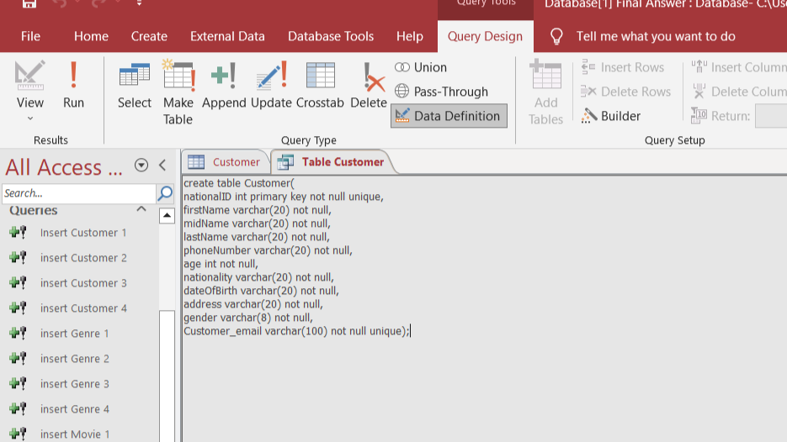

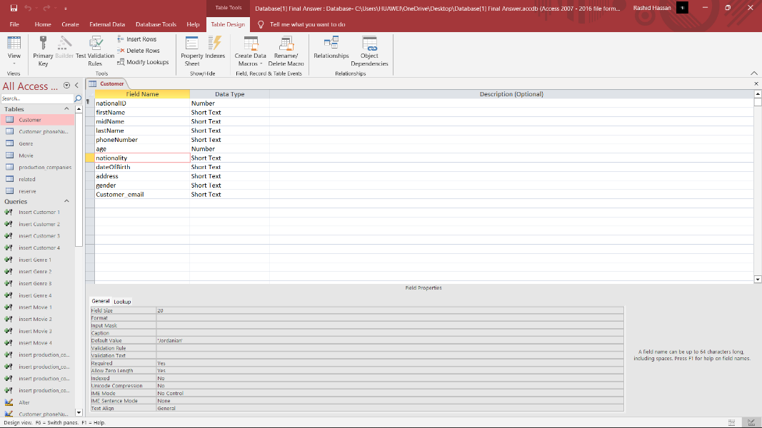

Based on the requirements, the customer must have an account in order to book the movie, so that we create a table for the customer in the database, which contains all the customer information, which are (National ID unique, Name, Mid name, Last name, phone number, Birth date, Gender, Address, Nationality default value, Customer Email unique).

Also, the schedule allows for multiple reservations for each customer and several customers for each reservation.

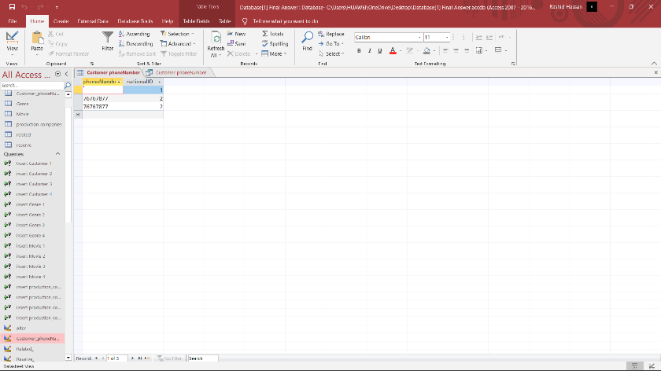

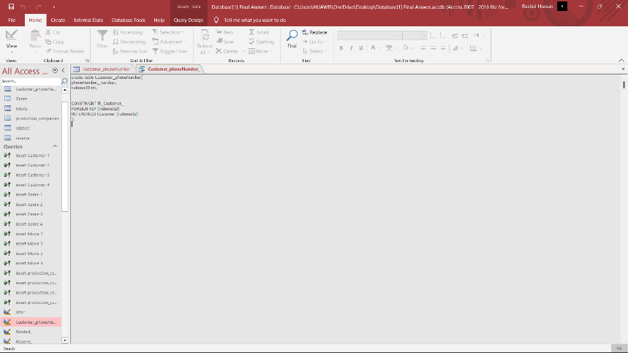

Also, based on the requirements, we created a table named Customer_phoneNumber. We created a table because it is the multivalued customer number.

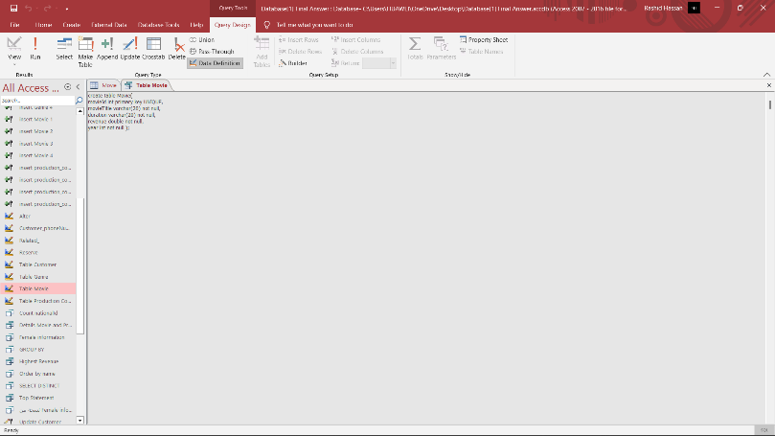

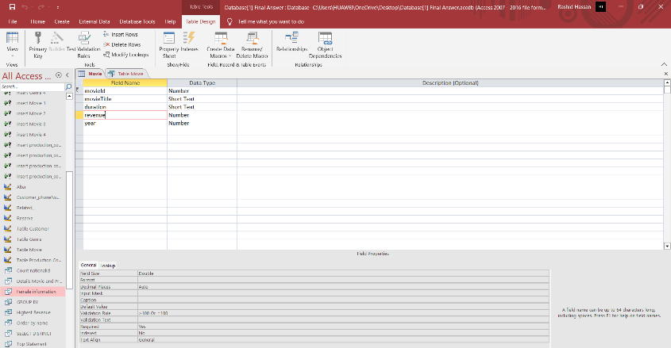

Based on the requirements, all detailed information about each movie must be obtained by creating a movie table in the database, which contains (Movie id UNIQUE, Movie title, year, duration, revenue).

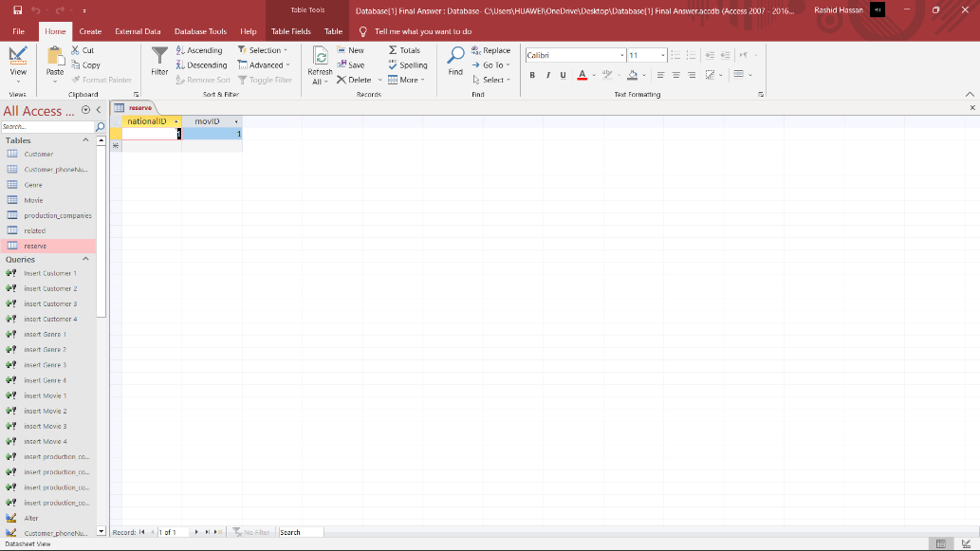

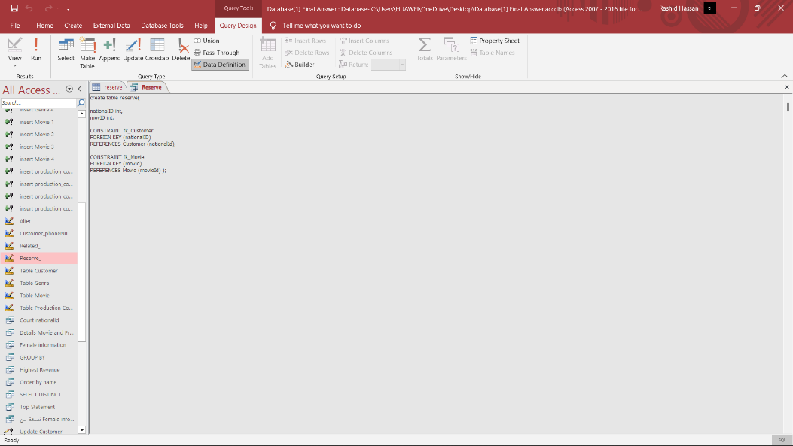

Also, based on the requirements, we created a table called Reserve that connects the customer table via the national ID and the movies table via the movie ID many to many relationships between the tables we have a relationship between customer table the movies table.

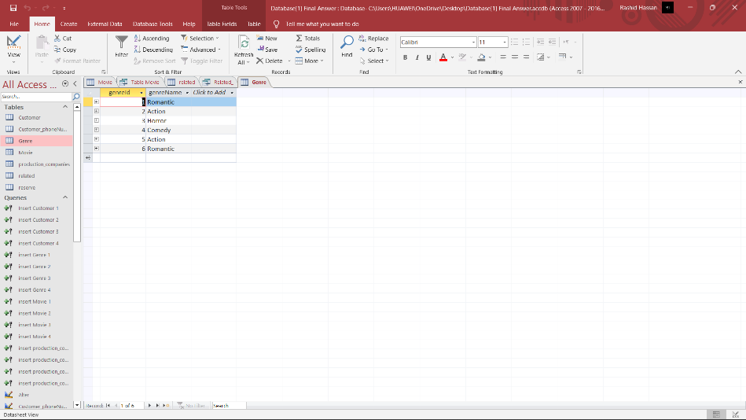

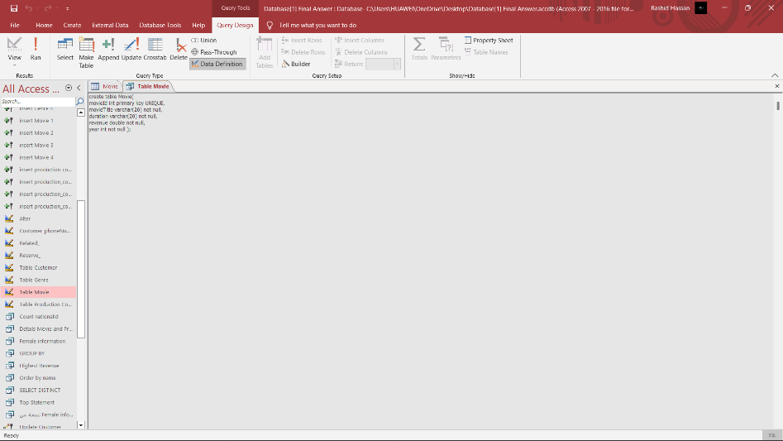

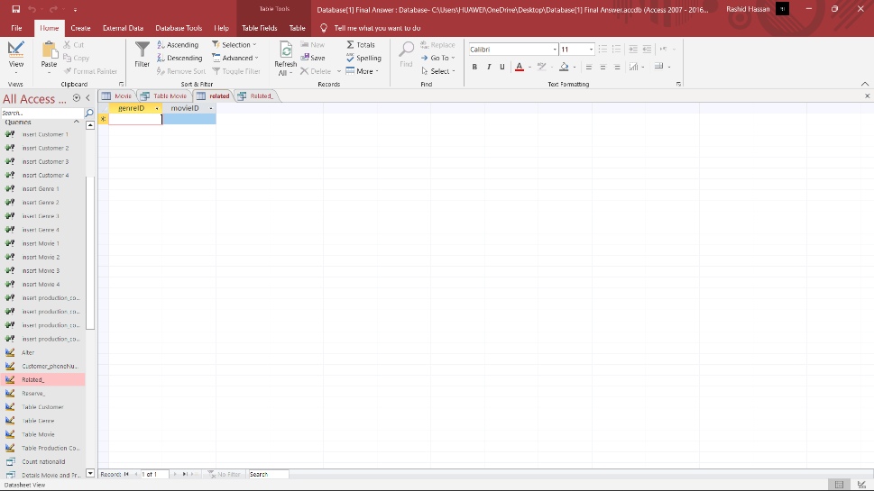

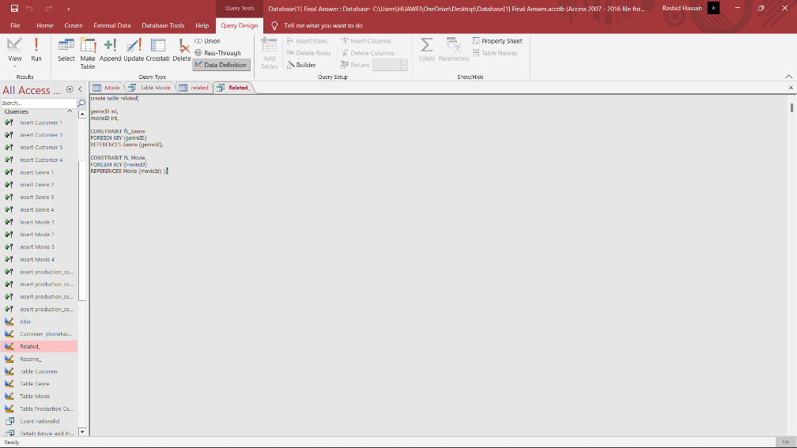

Based on the requirements in order for us to allow movies to belong to one or more genres, if a genre table is created that contains information about (genre id UNIQUE, genre name) then to create many to many relationships between the tables we have a relationship between movies and genres if we create a table named Related Stores the movie ID as well as the genre ID to link the two tables together.

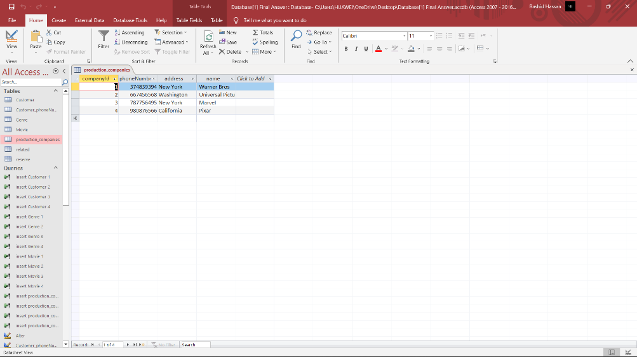

Based on the requirements, all detailed information about each production companies must be obtained by creating a production companies table in the database, which contains (Company id UNIQUE, name, address, phone number).

So based on the user and system requirements, the database solution implemented appears to meet all of the listed requirements.

In order to measure the compliance of the implemented database with the requirements, the following steps can be taken:

We verify that the registration system collects all required personal information and assigns a unique identification number to each customer.

To test customers' ability to book more than one movie and make sure that the booking is accurately reflected in the database.

We test the ticket purchase and retrieval feature to ensure that it works correctly and that transactions are recorded in the database correctly.

We verify that the search feature allows customers to search for movies, find out the specific movie genre, book the movie and other additional services.

To make sure that the website or application is easy to use and navigate for the user.

We test feature personalization to ensure that it tailors the user experience based on factors such as location, past behavior, and preferences.

We check the login screen to ensure that it allows users to access their account from anywhere at any time.

We verify that the search feature allows users to search for the movies they want.

Also, based on the evaluation, potential improvements that could be made to the database include:

We implement data validation to ensure that all personal information is entered correctly.

We implement a feature to allow users to cancel or modify their reservations.

Adding a feature for customers to view their purchase history and previous reservations.

To implement a feature for the customer to view his account details and update his personal information.

We improve the personalization feature by using advanced algorithms and machine learning techniques to personalize the user experience more effectively.

Enhance database security by implementing encryption and other security measures.

Finally, we improve the search feature by adding advanced filtering and sorting options.

And to use the appropriate database management system according to the ERD you prepared, implement the database.

To carry out the necessary queries to perform the necessary procedures and obtain data that support the daily work of customers.

We create a straightforward interface to add, update and delete data in the database and put the validation techniques described in the requirements into practice.

We examine the implemented database solution against system and user requirements. List each criterion with the conditions and methods used to achieve it.

To evaluate the user and system requirements for the database system you're creating, provide a number of test cases.

Analyze the relevance and effectiveness of the test, and how conducting the test will make the test results relevant.

To identify two possible future directions that may increase the effectiveness of the system.

2. After implementing the database system, you need to test it by performing the following:

* 1. Report the test plan that you want to follow by identifying elements of the system that need to be tested and considering data that should be used to fully test the system.

**Answer:**

First, database testing is a type of software testing that checks the schema, drivers, etc. of the database under test.

And the importance of data testing, that we check the database for duplicate columns and rows and double check the data types.

So, the test data types:

-Tables and columns test, which is to check the data types in the database for field values in the front end, check the length of the data field in the database for the length of the data types in the application, and also check if there are any tables or columns that are not included in the database of field objects Apply and validate the keys and indexes in the database and also check whether the primary keys and corresponding foreign keys are the same in the two tables, we check the unique and non-null properties of the keys are preserved, and finally maintain the length and data type of the keys and indexes according to the requirements, validation data Verifying that the data entered into the system complies with the rules and restrictions specified in the requirements (for example, the revenue of each film must be at least $100, and the nationality was filled with “Jordanian” by default if it was not provided). Test this by entering various data into the system and checking that the system applies the rules and restrictions correctly.

Also, we test the individual units of the database, such as tables, views, and stored procedures, to make sure that they perform or work well.

Search function, verify that the search function correctly returns the correct movie based on the search criteria provided. Test this by searching for movies using different combinations of search criteria (such as title, genre, and production company) and checking that the correct movie is returned.

Reservation Function, verify that customers can book movies correctly and that reservation information is stored correctly in the system. Test this by creating test accounts, booking movies, and checking that booking information is stored and displayed correctly in the system.

Functional testing, which is a functional procedure that takes into account the end user's point of view, i.e., whether the required transactions and operations managed by customers or end users meet the business specifications and also to ensure that they do or meet all requirements

Data Integrity, verify that data stored in the system is consistent, accurate, and complete. Test this by inserting, updating, and deleting test data, and verifying that the system maintains data integrity and returns correct data when queried.

Error Handling, verify that the system handles errors and exceptions correctly. Test this by intentionally causing errors and exceptions (for example, by entering invalid data or entering data in the wrong format) and verify that the system returns appropriate error messages and handles errors correctly.

Non-functional testing, which includes performing load testing, stress testing, scanning and system performance, minimum system requirements to meet business specifications, risk detection, and database performance optimization.

- Testing databases to check the integrity of the data and ensure the integrity of the data and you need to review the main columns in each table and check for any incorrect data and also detect inconsistent data and enter it in the relevant tables and check if any failure occurred and also if the data was updated in a table , Check if other related data has also been updated. You need to ensure that the replicated servers or databases are in sync and contain consistent information.

The load test checks the response time for executing transactions for multiple remote users, as well as the time it takes for the database to fetch specific records, for example, performing the most frequently used transactions to see the performance of the database system, as well as downloading a series of large files from the Internet, and finally running multiple applications on the computer or server at one time.

Security, verify that the system is secure and that sensitive data is protected. Test this by trying to access the system using invalid credentials, attempting to hack the system, and verifying that the system keeps the data safe and sound, such as adding a password to the database that we have created to enhance the security of the information and data stored in it.

b. List the procedures to be used in testing (white box testing, black box testing)

**Answer:**

First, black box testing is a testing method where the tester is aware only of the inputs and outputs of the system being tested, but not the inner workings or implementation of the system. Focuses on testing system functionality and ensuring that it meets specified requirements. Testers don't need to know how the system works in order to test it, they just need to know what the system is supposed to do and black box testing is used by creating interfaces and adding buttons and boxes for the user without any code done by Design View from Microsoft Access.

Second, white box testing. White box testing includes testing the internal logic and structure of the system. The tester has knowledge of the inner workings and implementation of the system, and tests the system by examining its code and structure. The goal of white box testing is to ensure that code is correct, efficient, and maintainable. This method makes it easy to identify flaws in business logic or application design. Examples of white box testing methodologies include statement coverage and decision coverage. White box testing is used by testing SQL code and query testing. per statement and per table.

Third, Gray box test which is a combination of black box and white box testing. This test method combines the external function test of the black box test and the internal structure test of the white box test.

In gray box testing, the tester has some knowledge of the inner workings and implementation of the system, but not complete knowledge. They are familiar with the system's inputs, outputs, and some internal structure. This allows them to test the system at different levels, from external functionality to internal code, and also to identify potential integration issues between the various components of the system.

Gray box testing can provide a more comprehensive view of the system and can help identify problems that might not be found using black box or white box testing alone. It is particularly useful for systems that have complex internal structures and interactions between components.

By applying black and white box testing or both to the database, we can ensure that the database meets the requirements and operates from an external and internal perspective. Black box testing can ensure that the database is able to handle the required input and return the expected results,

while white box testing can ensure that the internal components of the database are working as intended and that the database is optimized for performance. Together, they help ensure the overall quality, reliability, and integrity of the database.

c. Based on the test plan you have given in the previous point, check the system against user and system requirements. In addition, provide relevant test cases **(at least 5 test cases)** for the database you have implemented.

**Answer:**

1- Null value checks:

The value or field must not be an empty value.

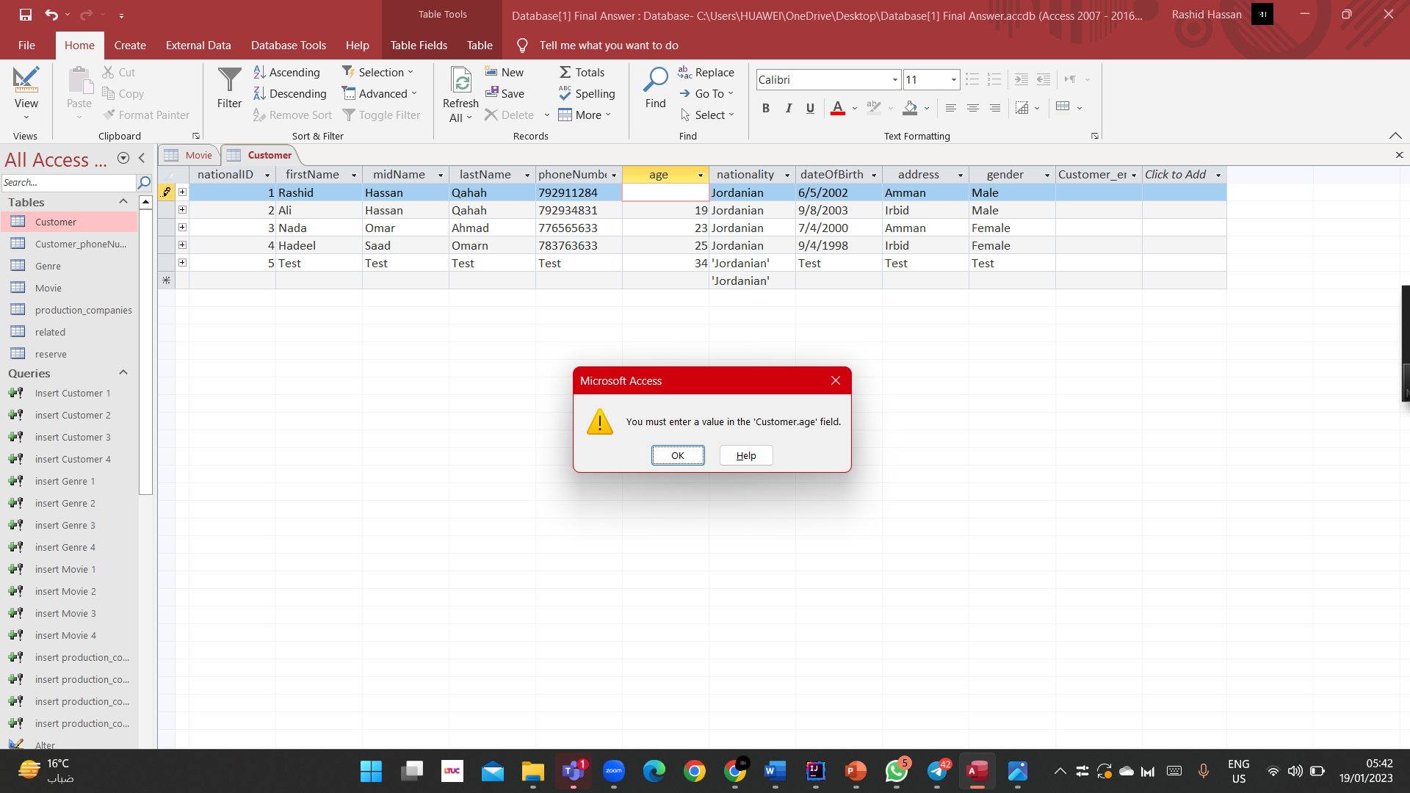

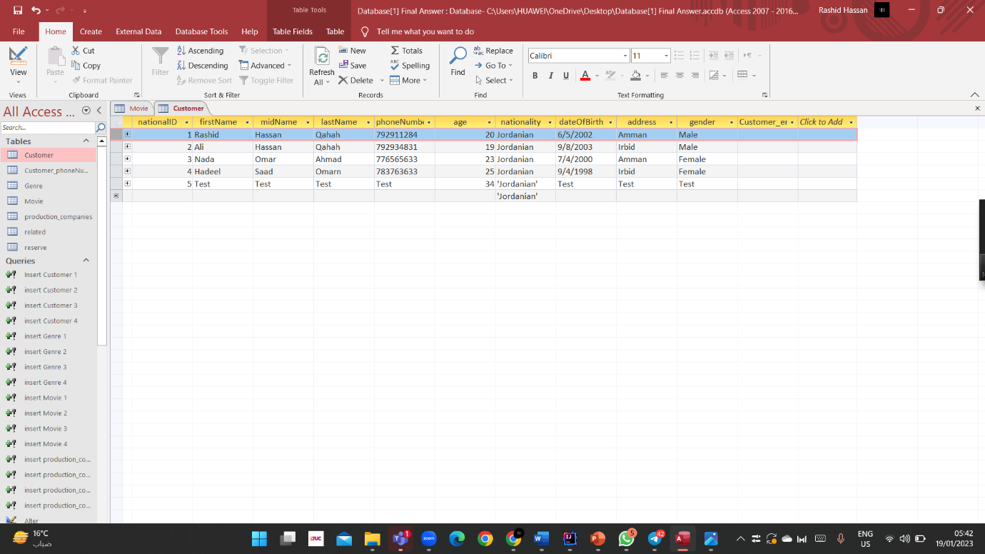

2- validation check:

When entering a revenue of 50, it does not comply with the condition or validation that we have set.

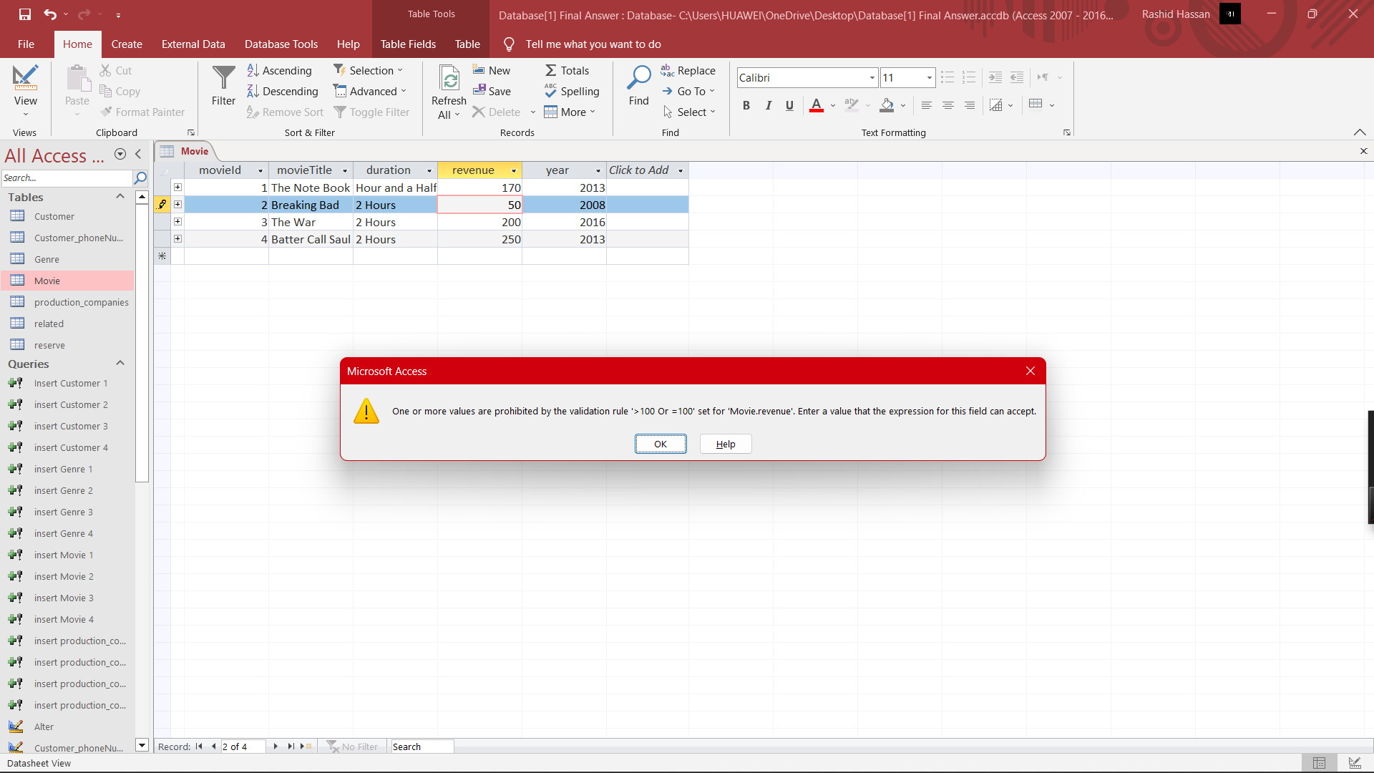

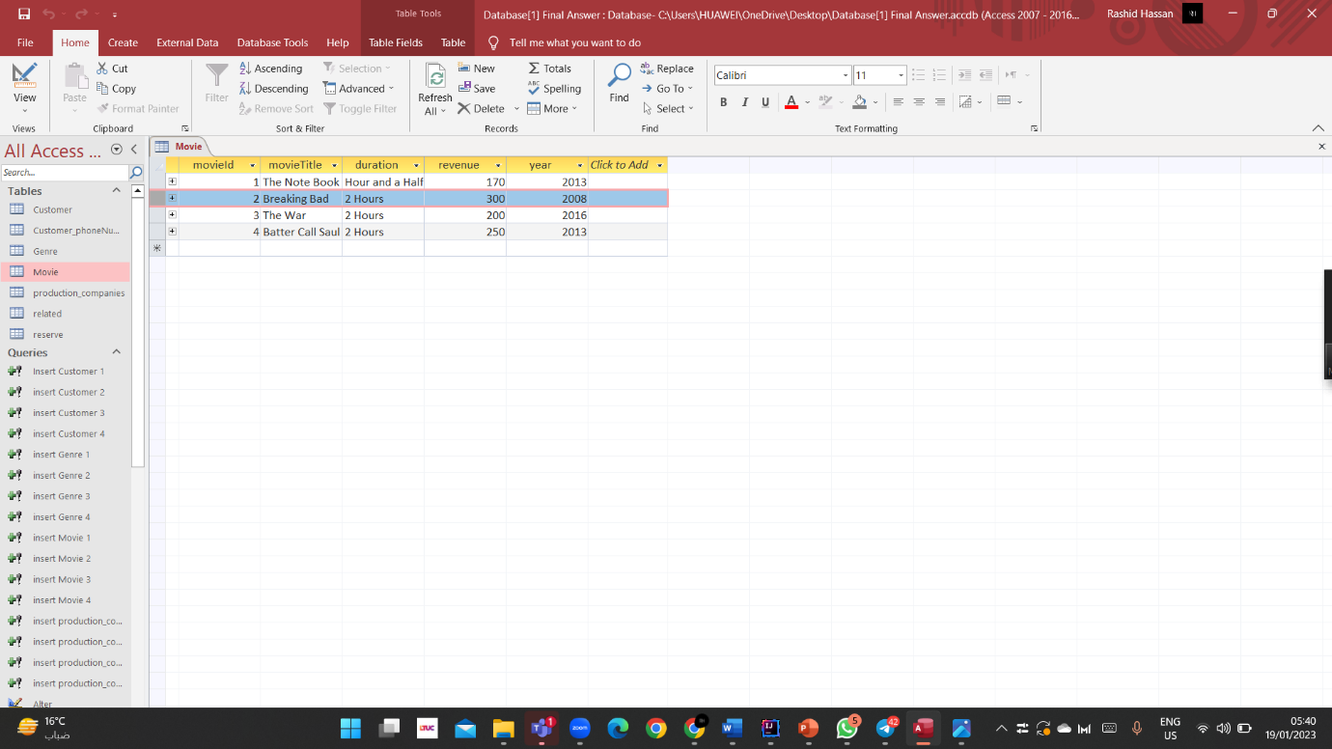

3- Test Verify key primary key:

The identifier primary key or cannot be an empty value.

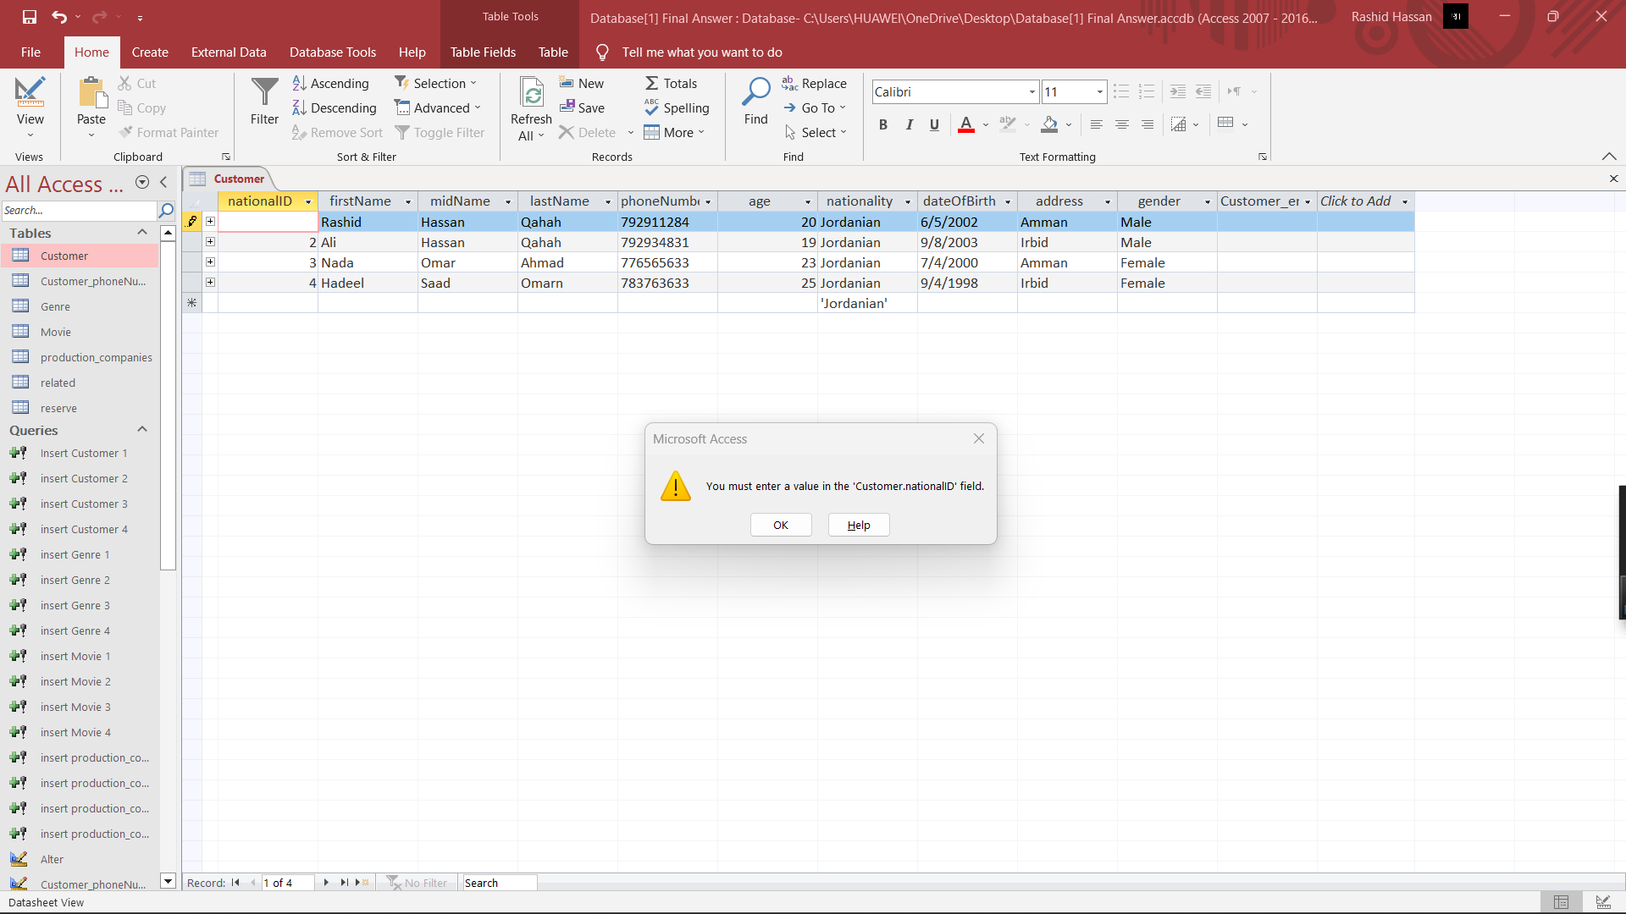

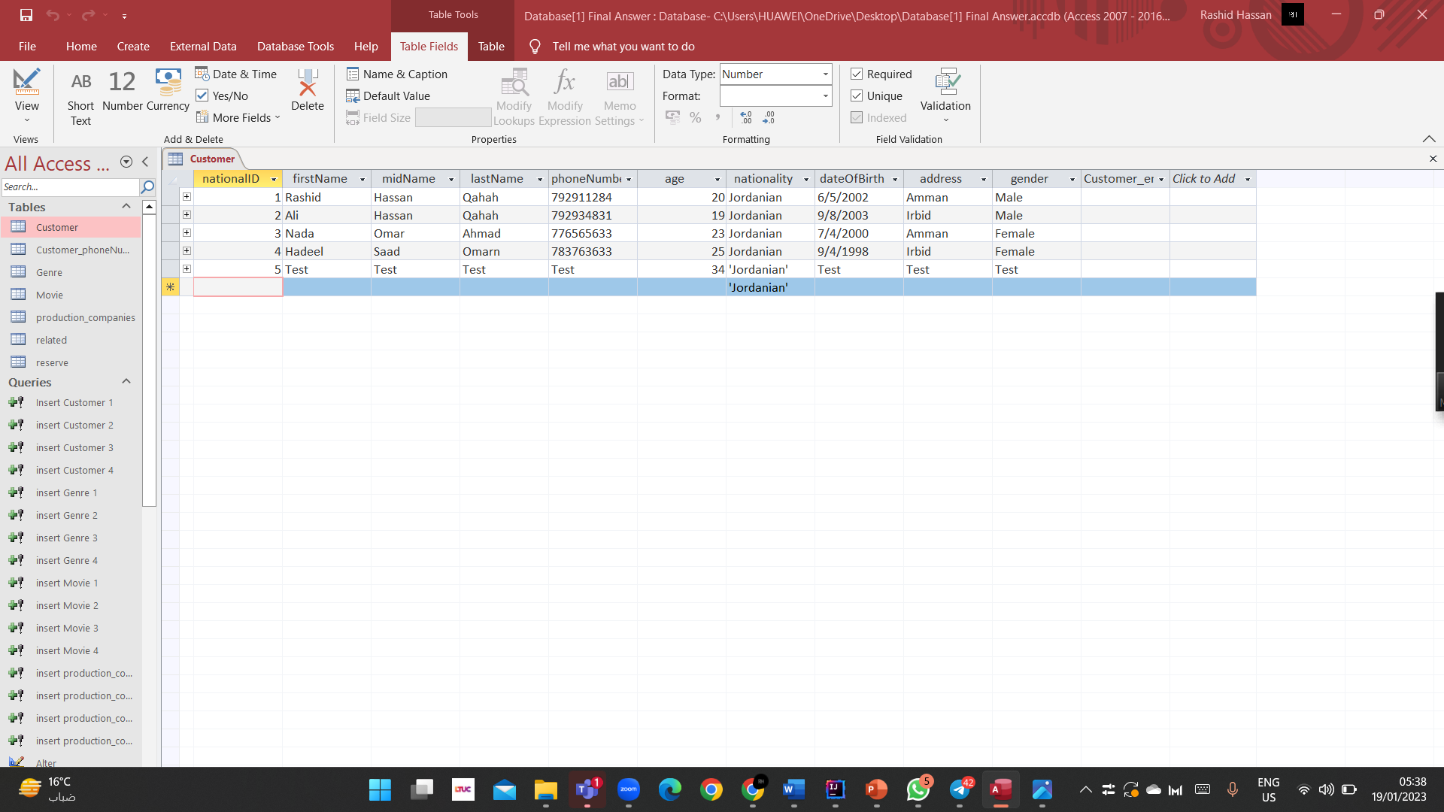

4- Test Verify keys foreign key:

There is no primary key number 66 in the movie Table.

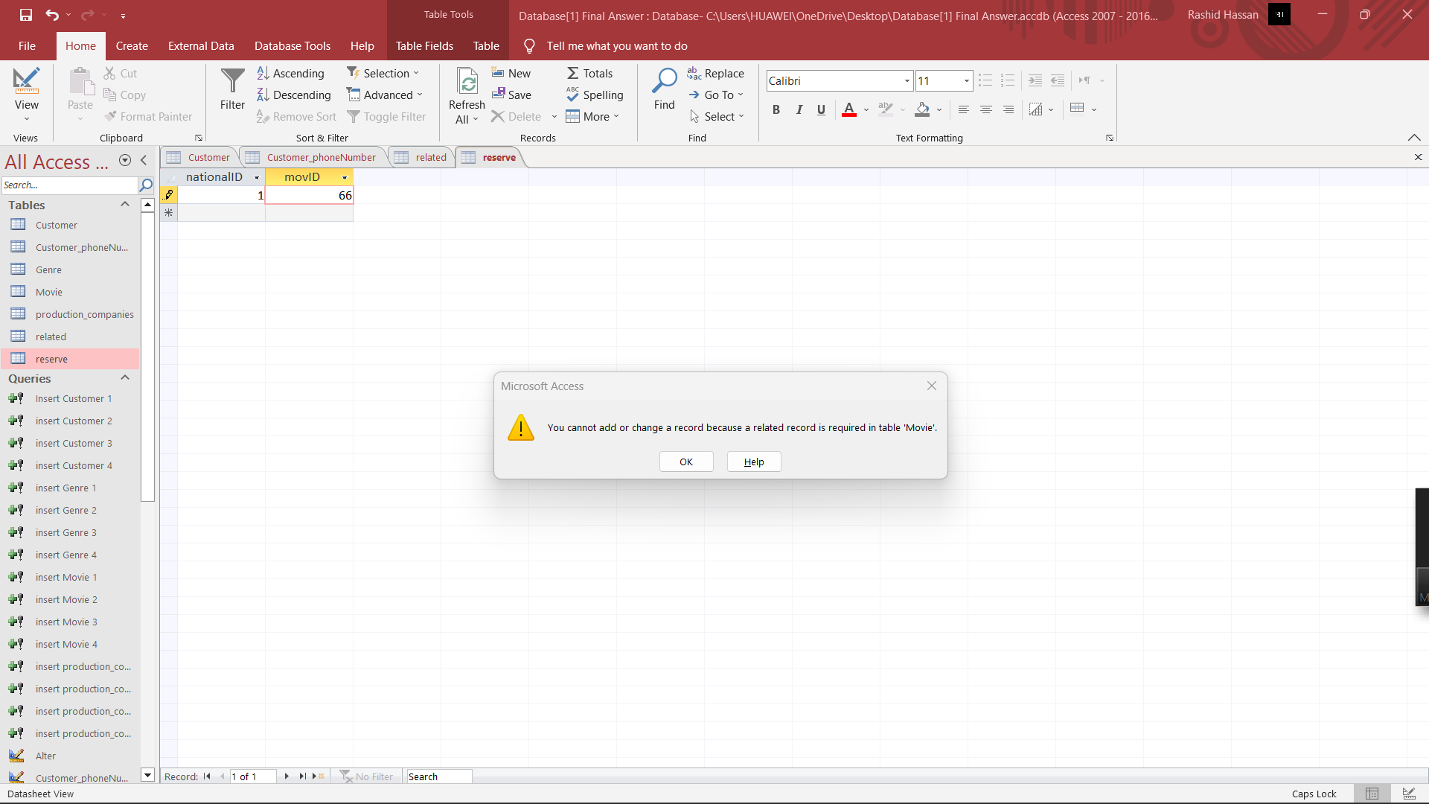

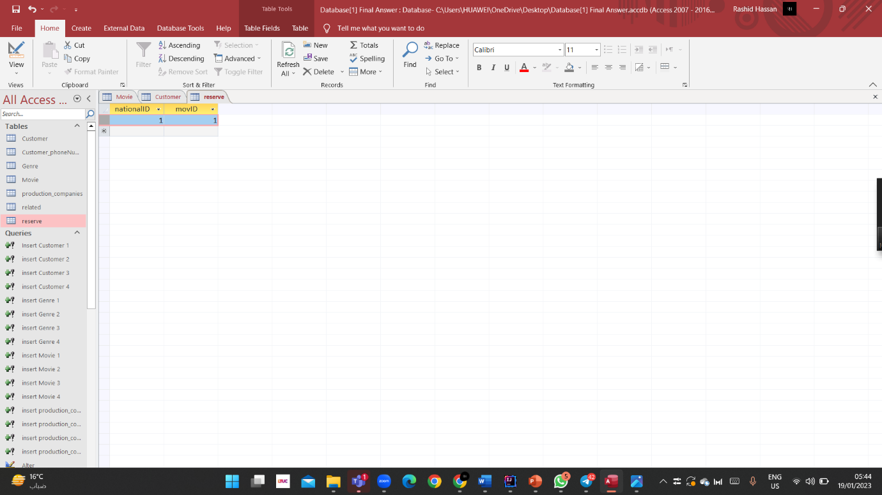

5- We check if the value is similar to the previously entered value, because the e-mail is unique, and each customer must have a different e-mail from the other.

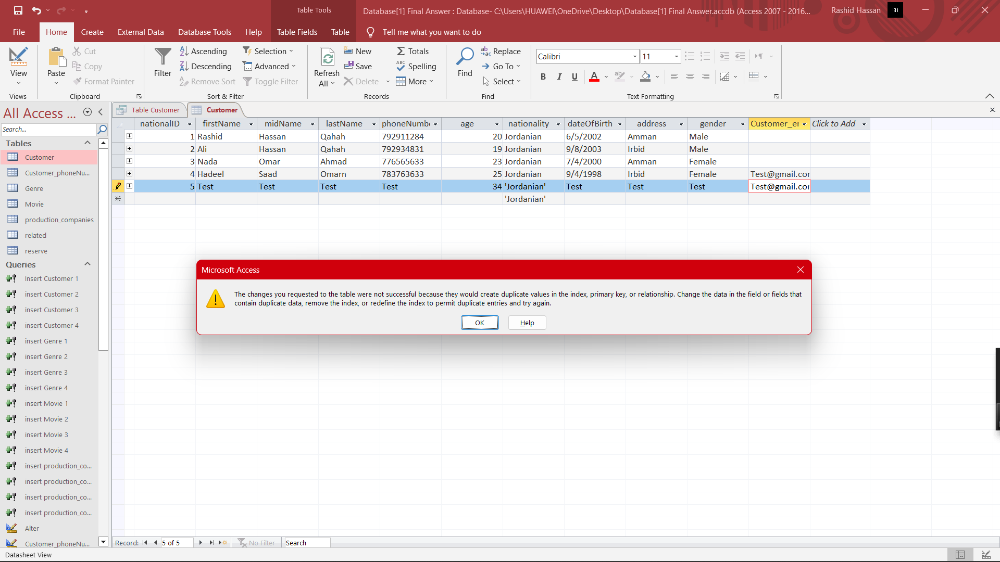

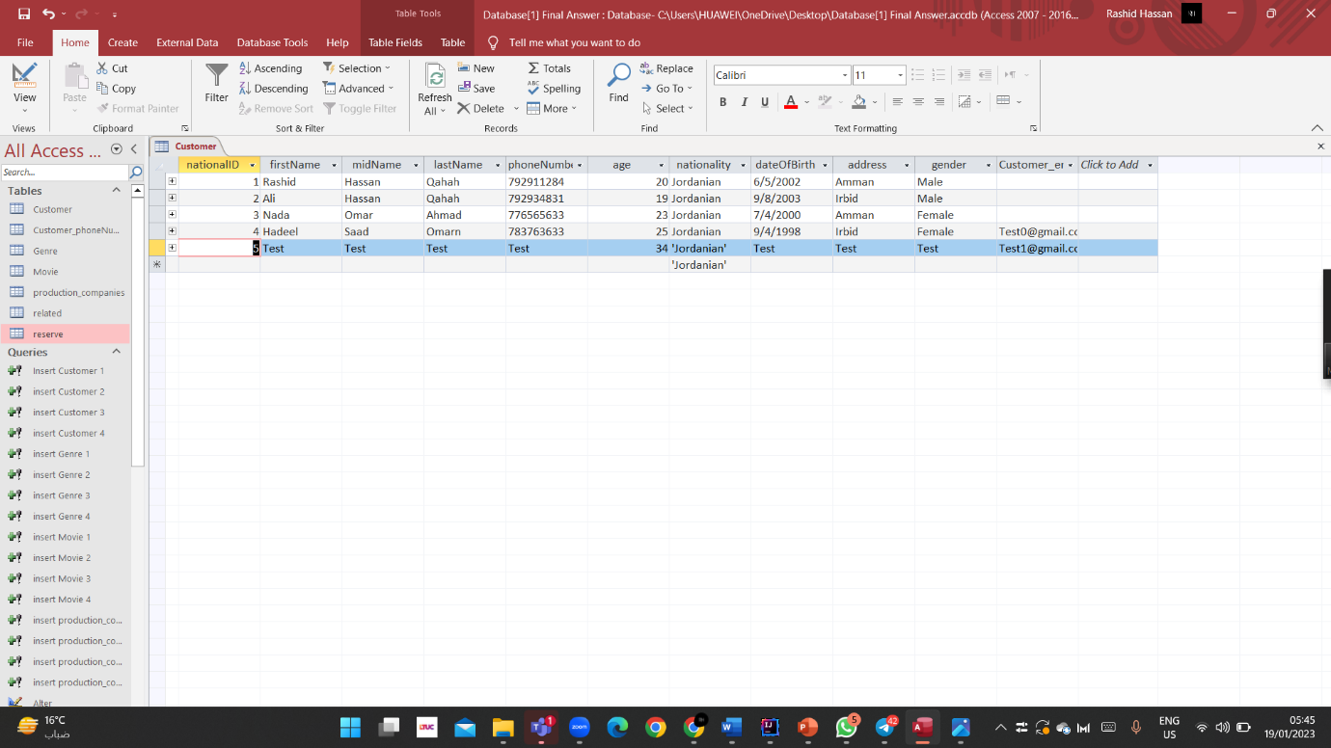

d. Evaluate the effectiveness of your testing, by showing how were your test cases helpful to find out if the system is correct and complete or not.

**Answer:**

First, we evaluated the effectiveness of testing the database system for Movie Zone Cinema by doing a functional test by making sure that the system meets all functional requirements such as the ability of customers to search for a movie, know the specific type of movie, and book other additional services by verifying that it has these functions. It works as required, which was as required and expected, and we were also able to verify the correctness of the system as well.

We were also able to test the performance of the system, so we evaluated the system under different loads and conditions by testing the time and response times of the system and its scalability under different loads with the expected number of clients and transactions.

Also, we evaluated the integrity of the data and thus from tests to ensure that the data entered into the system is accurate and consistent, and through testing the restrictions of the system and validation checks, we made sure that the system imposes rules and restrictions such as the revenue of each movie should not be less than 100 dollars and that the national identity of each customer is unique from its kind.

We also made sure, through acceptance testing, that the system meets all the expectations of end users in the testing process, and we also made sure that the system is easy to use and meets customer needs.

We were also able to verify the security test and set a password for the database to ensure that the system is secure and that sensitive data is protected by testing system encryption, access controls and audit mechanisms, and also enables us to ensure that the system is secure and that the data is protected from unauthorized access.

Finally, we made sure of Regression Testing by making sure that the changes made to the system do not lead to errors, regressions, or new problems. The new ones or the experiments that we have done are only a test of the system and to ensure that it is correct and that the changes do not affect current functions.

In general, with this set of test methods, we can ensure that the Movie Zone Cinema database system is correct, complete, and meets the needs of end users.

3. Assess the implemented database by discussing improvements that could be made over the system, keeping its quality attributes like: scalability and maintainability.

I would evaluate the database's performance and identify any areas for improvement once it has been implemented and tested. Some possible areas of focus include:

Scalability: As the number of customers and transactions grows, it's critical to ensure that the database can keep up. This could include optimizing queries and indexing, as well as considering horizontal scaling techniques such as sharding or replication.

Maintainability: It is critical for ongoing development and maintenance to keep the database organized and simple to understand. This could include regular performance tuning, database refactoring, and implementing best database design and management practices.

Data Security: To ensure the security of sensitive data, I would consider implementing security features such as encryption, access controls, and auditing.

Data Backup and Recovery: To ensure that the data is secure and easily recoverable in the event of a problem, I would consider developing a database maintenance and backup strategy. This could include performing regular backups, monitoring the database for problems, and testing the recovery process.

Overall, these enhancements would aim to make the database more stable, performant, and easy to maintain over time.

In addition to the previously mentioned points, there are a few more specific areas that could be improved:

Queries must be optimized as the database grows to ensure that response times are minimized and slowdowns are avoided. Creating indexes, optimizing query design, and identifying and addressing any performance bottlenecks could all be part of this.

Redundancy and Failover: Implementing redundancy and failover mechanisms to ensure high database availability may be beneficial. Setting up database replication or using a load balancer to distribute traffic across multiple database servers could be part of this.

Data Integrity: It is critical to implement data integrity constraints and validation checks to ensure that the data stored in the database is accurate and consistent. This may entail using constraints like primary and foreign keys, as well as triggers and stored procedures to validate data before it is inserted or updated in the database.

Data Governance: Implementing data governance best practices can help ensure that the data stored in the database is properly managed and governed. This could include developing data policies and procedures, establishing roles and permissions, and putting in place data auditing and monitoring mechanisms.

Monitoring and reporting: It is critical to implement monitoring and reporting mechanisms to ensure that the database runs smoothly. Monitoring key performance indicators, creating alerts for potential issues, and generating reports on database performance and usage could all fall under this category.

Overall, these enhancements would aim to make the database more stable, performant, and simple to maintain over time. This will also ensure that the system can handle a large number of customers and transactions, which is essential.

You are also required to document your work and generate an organized **technical documentation** that includes system requirements and functionalities, **flowchart** **diagram**, user manual, interfaces and so on…. ….

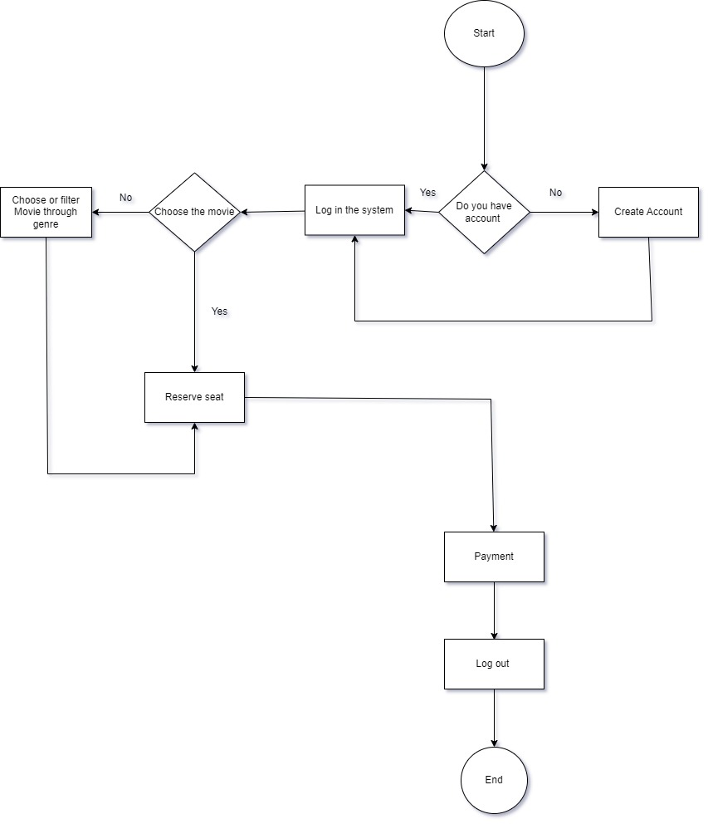

**Plagiarism**

Plagiarism is a particular form of cheating. Plagiarism must be avoided at all costs and students who break the rules, however innocently, may be penalised. It is your responsibility to ensure that you understand correct referencing practices. As a university level student, you are expected to use appropriate references throughout and keep carefully detailed notes of all your sources of materials for material you have used in your work, including any material downloaded from the Internet. Please consult the relevant unit lecturer or your course tutor if you need any further advice.

**Student Declaration**

|  |
| --- |
| **Student declaration**  I certify that the assignment submission is entirely my own work and I fully understand the consequences of plagiarism. I understand that making a false declaration is a form of malpractice.  Student signature: Rashed Hassan Date: 18/1/2023 |